42: Multi-Axis Cobot For Factory Automation

Adrian Guzman, Emily Hamsa, Ethan Woods, Jaishil Shah

**Subsystem Reports**

REVISION – Draft

1 December 2024

Subsystem Report

for

42: Multi-Axis Cobot For Factory Automation

Prepared by:

_____________________________

Author Date

Approved by:

_____________________________

Project Leader Date

_____________________________

John Lusher II, P.E. Date

_____________________________

T/A Date

**Change Record**

| **Rev.** | **Date** | **Originator** | **Approvals** | **Description** |
| --- | --- | --- | --- | --- |
| **0** | 12/1/2024 | All Members | All Members | Draft Release - Revision 0 |

**Table of Contents**

**Table of Contents III**

**List of Tables IV**

**List of Figures III**

**1. Overview** **1**

**2. Motor/Motor Driver Subsystem**

2.1. Subsystem Introduction

2.2. Subsystem Details

2.2.1. Torque Calculations and Motor Selection

2.2.2. Motor Movement

2.2.2.1. DRV8161 Motor Driver

2.2.2.2. PCB Design and Creation

2.2.2.3. Testing and Results

2.3. Subsystem Validation

2.4. Subsystem Conclusion

**3****. MCU/Processing Subsystem**

3.1. Subsystem Introduction

3.2. Subsystem Details

3.2.1. Subsystem Block Diagram

3.2.2. PCB Schematic Design

3.2.2.1. General-Purpose Input/Output (GPIO)

3.2.2.2. Power

3.2.2.3. Programming (JTAG)

3.2.2.4. Miscellaneous

3.2.3. C2000 Launchpad Development

3.2.4. PCB Testing and Results

3.2.4.1. Power

3.2.4.2. Programming

3.2.4.3. PWM Waveform Generation

3.2.4.4. Communication with ESP-32

3.3. Subsystem Validation

3.4. Subsystem Conclusion

**4****. Power & Battery Management Subsystem**

4.1. Subsystem Introduction

4.2. Subsystem Details

4.3. Subsystem Validation

4.4. Subsystem Conclusion

**5. User Interface & Wireless Connectivity Subsystem** 5.1. Subsystem Introduction

5.2. Subsystem Details

5.3. Subsystem Validation

5.4. Subsystem Conclusion

**List of Tables**

Table X: C2000 Pinout (Signals sent to 3x Motor Drivers)

Table X: C2000 Pinout for ESP-32 Connectivity

Table X: Validated Deliverables

**List of Figures**

Figure X:

Figure X:

Figure X:

Figure X:

Figure X:

Figure X:

Figure X:

Figure X:

Figure X:

Figure X:

Figure X:

Figure X:

Figure X:

Figure X:

Figure X:

Figure X:

Figure X:

Figure X:

Figure X:

Figure X: MCU/Processing Block Diagram

Figure X: GPIO PCB Schematic

Figure X: Power PCB Schematic

Figure X: JTAG Programming PCB Schematic

Figure X: Miscellaneous PCB Schematic

Figure X: LED Blinky

Figure X: MicroServo 9g SG90

Figure X: Stepper Motor w/ ULN2003 Motor Driver

Figure X: PWM Signal Modulation

Figure X: Front & Back of PCB

Figure X: 3.3V Input to Terminal Block

Figure X: Successful JTAG Programming Method

Figure X: Programming through Launchpad

Figure X: Successful Connection

Figure X: PWM Generation EPWM7A & EPWM7B

Figure X: PWM High/Low Generation

Figure X: ESP-32 to C2000 Communication (LED Toggle)

# Overview

The multi-axis cobot for factory automation will be able to lift and move objects wirelessly to improve productivity, minimize worker injury, and work in dangerous environments. The cobot will take user input through a mobile app and then move according to the input. The system is broken down into four subsystems, motor/motor driving, MCU/processing, power/battery management, and user interface/wireless connectivity. Each team member has researched, developed, and tested their individual subsystem. The validation and execution plans have been followed closely to ensure an easy path to integration in the following semester.

# Motor/Motor Driver Subsystem

## 2.1. Subsystem Introduction

The Motor/Motor Driver Subsystem is responsible for controlling the movement of the Collaborative Robot (Cobot) through the selection and control of the motors. This subsystem focuses on identifying the motors capable of handling the calculated torque requirements for the different joints in the Cobot. These motors are driven using Texas Instruments’ DRV8161 Motor Drivers, which controls the 3-Phase Brushless DC (BLDC) motors using generated PWM signals.

To achieve motor movement, custom PCBs were designed and fabricated with the primary goal of spinning a 3-phase BLDC motor. These boards integrate key functionalities, including voltage step-down circuits, Motor Driver circuits, and connections for phase signal generation, inspired by the Texas Instruments’ DRV8161 Evaluation Module. The PCB system consists of a main board and two supporting boards, collectively enabling control and high-performance operation of the motor. The design ensures compatibility with the LAUNCHXL-F280049C, a Texas Instruments’ C2000 Launchpad Development Kit, and supports the high torque, voltage, and current requirements of the motor.

***2.2. Subsystem Details***

During this semester, the subsystem had two main goals: **Motor Selection** and **Motor Movement**. The first goal was to calculate the necessary torque needed for each motor in the Cobot to accommodate its maximum payload, desired dimensions, and material weight. Based on these calculations, five motors were selected—one for each joint: Base, Arm 1, Arm 2, Neck, and Head. All motors except for the Head are 3-phase BLDC motors, chosen for their precision and compatibility with the DRV8161 Motor Drivers.

The second goal was to move and spin one of the selected motors. To achieve this, the DRV8161 Motor Drivers were used to generate the three phases required for the operation of a 3-phase BLDC motor. This involved designing and creating a system of PCBs that worked together to generate and route the necessary signals for motor control. The motor was connected to a main board, which ensured it received all the signals needed for movement and allowed control through an external device.

***2.2.1. Torque Calculations and Motor Selection***

At the start of the semester, we met as a group to conceptualize the operation and movement of the Cobot and establish its primary constraints. As a Collaborative Robot, we envisioned the Cobot being capable of smooth and unrestricted movement within its range of motion. This discussion led to the decision of implementing a 5-Degree of Freedom (DoF) design, requiring five motors—one for each joint. At this stage, we focused solely on the degree of freedom and the maximum payload the Cobot should handle, without delving into details about its material composition or dimensions.

With this conceptual framework in place, we could now begin analyzing the conditions under which the motors would operate. Using free-body diagrams and calculations, we defined the assumptions and constraints necessary to determine the torque range required for motor selection. Below is the process taken to determine the torque range required for each motor. Calculations will not be provided and instead are in the document linked below.

*These calculations and results are presented in the document:* [*Motor Calculations*](https://drive.google.com/file/d/1-wp_XzNhOnYnFOjFMtRx3apCVsc_YNEo/view?usp=sharing)

*If the link does not work, send concerns to* [*ewoods738@tamu.edu*](mailto:ewoods738@tamu.edu) *or (210)774-0465*

To calculate the required torques for each of the five motors in our conceptual Cobot, we began by translating the design into a 5-jointed robotic arm representation. This step allowed me to visualize the system and create the free-body diagram (FBD) shown below, which depicts the robotic arm in its worst-case scenario. By analyzing this worst-case configuration, we ensure the torque calculations are overestimates, providing a safety margin in the design rather than risking underestimations. Below, is the conceptual 5-DoF design and the corresponding free-body diagram used as the basis for the torque calculations.

Figure X: Conceptual Design and Free-Body Diagram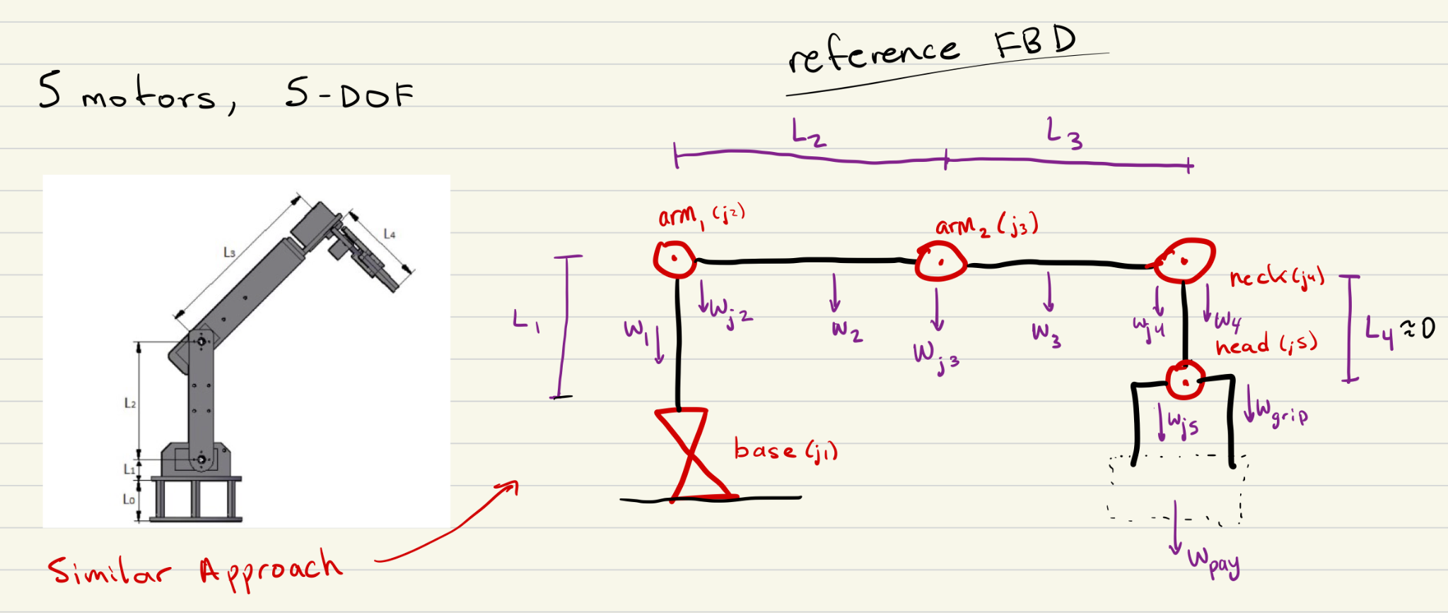

With the creation of the free-body diagram (FBD), we were now able to determine the forces acting on each joint and, in turn, calculate the gravitational or angular torque required for each motor. Motors that lift (Arm 1 and Arm 2) require gravitational torque calculations, while those responsible for rotation (Base and Neck) require angular torque calculations. To account for variability in the Cobot's design, the torque requirements were classified into three ranges: **Low Torque**, **Medium Torque**, and **High Torque**.

* **Low Torque** represents a smaller and lighter-than-expected design.
* **Medium Torque** reflects the expected design based on our initial assumptions.
* **High Torque** assumes a heavier, overestimated design to ensure safety margins in the motor selection.

By calculating the torque for each motor across these three ranges, I was able to establish a torque range for each joint. This range gives a great indicator in selecting the optimal motor for each application.

**Torque Categories: Differences and Similarities**

The differences between the torque ranges are based on varying constraints such as arm length, material density, and acceleration. However, certain assumptions, such as the payload and the gripper motor's specifications, remained consistent across all categories. The table below summarizes these differences and similarities:

Table X: Differences and Similarities between Torque Categories

| **Category** | **Base and Neck Acceleration** | **Weight of**  **Arms (Material Density,Cross-**  **Section)** | **Length of Arms** | **Payload Weight** | **Gripper Motor Weight/**  **Length** | **Joint Motor Weight** |
| --- | --- | --- | --- | --- | --- | --- |
| **Low Torque** | Reduced | Lower density,  smaller cross-  section | Shorter | Fixed (2  lb / 0.91 kg) | Fixed* (Amazon Servo Motor) | Fixed/  Estimated** |
| **Medium Torque** | Average/  Expected | Average density and cross-section | Average/  Expected | Fixed | Fixed* | Fixed/  Estimated** |
| **High Torque** | Increased | Higher density, and larger cross-section | Longer | Fixed | Fixed* | Fixed/  Estimated** |

* The motor and claw specifications are on Amazon. These were used during calculations.

** Weights were estimated based on the average weights of different motors that could be used during the project. Ended up being 1.4 kg for Joint 2, 0.8 kg for Joint 3, and 0.25 kg for Joint 4.

With the completion of the torque calculations, we were now able to determine the estimated torque requirements for each motor in the Cobot across the three categories: Low Torque, Medium Torque, and High Torque. These calculations provide a clear range of torque values for each joint—Base, Arm 1, Arm 2, Neck, and Head—ensuring the motors selected can handle both expected and extreme conditions. The table below summarizes the calculated torque values for each motor in all three categories, serving as the foundation for motor selection and design optimization.

Table X: Motor Torque for Each Category

| **Motor** | **Low Range Torque** | **Mid Range Torque** | **High Range Torque** |
| --- | --- | --- | --- |
| **Base Motor** | .1428 N/m** | .5339 N/m | 1.993 N/m |
| **Arm 1 Motor** | 563 oz-in*** | 1197 oz-in | 2763 oz-in |
| **Arm 2 Motor** | 181.72 oz-in | 354 oz-in | 745 oz-in |
| **Neck Motor** | .00649 N/m | .00973 N/m | .0129 N/m |
| **Gripper Motor\*** | 11 kg/cm | 11 kg/cm | 11 kg/cm |

* Gripper Motor is bought off Amazon. Cannot change the value of the torque produced or required for the Gripper Motor as 11 kg/cm should be more than enough for 2 lbs.

** N/m is the measurement for angular torque, as it is the amount of torque needed to produce the acceleration necessary for the Base and Neck motors

*** oz-in is a measurement of torque in relation to gravity. It shows the lifting power needed for that motor to lift a payload of 2 lbs when considering the entire design of the Cobot.

**Motor Selection Based off Estimated Torque Range**

With the established torque ranges for each joint, we could now select motors that meet the performance requirements while aligning with the constraints of the Cobot's design. The motors chosen are high-power, 3-phase BLDC motors, capable of handling the calculated torque for their respective joints. The table below highlights the selected motors, along with their key specifications such as voltage, current, torque output, and cost, ensuring they are well-suited for their designated roles in the Cobot.

Table X: Selected Motors for 5-DoF Collaborative Robot

| **Motor** | **Name** | **Link** | **Torque** | **Rated Voltage** | **Rated Current** | **Encoder Type** | **Weight** | **Price** |
| --- | --- | --- | --- | --- | --- | --- | --- | --- |
| **Base** | 57BSA | [link](https://www.omc-stepperonline.com/48v-3000rpm-0-6nm-188w-5-40a-57x57x100mm-brushless-dc-motor-57bsa100-48-01) | 0.6 N/m | 48 V | 5.4 A | Hall | 1.35 kg | $59 |
| **Arm 1** | NEMA 34 Hudson | [link](https://teknic.com/hudson-model/M-3432S-LN-02D/?model_voltage=48) | 1223 oz-in | 48 V | ~10 A  max:  20 A | Differential/Hall | 2.8 kg | ~$360 |
| **Arm 2** | NEMA 23 Hudson | [link](https://teknic.com/hudson-model/M-2311P-QN-08D/?model_voltage=48) | 223 oz-in | 48 V | ~ 10 A  max:  30 A | Differential/Hall | 0.6 kg | ~$210 |
| **Neck** | 42BYA | [link](https://www.omc-stepperonline.com/24v-3000rpm-0-04nm-13w-1-00a-42x43mm-brushless-dc-motor-42bya43-24-01) | 0.04 N/m | 24 V | 1 A | Hall | 0.3 kg | $20 |
| **Head** | MG996R | [link](https://www.amazon.com/Professional-Mechanical-Educational-Raspberry-Platform/dp/B08WPZ9FGW/ref=sr_1_52?crid=27YZU0INICY5H&dib=eyJ2IjoiMSJ9.WCDSC5rzLEaM66dcxYARhpFdNj62xm0yeHtVYDBMxX1ZOXbzKWLye8swIAanG2pnp1dHjuPK2g4l2AcqQyuO8daYV-Q63bgGczpb6SgeX19-1c_hQ-FU0PSbZCNCrRKBNydat9FnVBKs7Wv2IVduUaBsoWC6UM2CH2L-YKS36ghfO9ToORUdCrr1OWvDNxHAB_uHCKFbxRCrzGTs04bxD_CyJr54uECMBbgCT_M9yHr-HHPjZBxoudh3OStVYXc9WQC_N-EYm_8LyNwo_a9SSlzJfU3fIUPinHSm75AlQDA.cV853680l-eolYdCzcXIyM_HxmuylG833f66PXE0lwo&dib_tag=se&keywords=robotic%2Barm%2Bgrabber&qid=1728328167&refinements=p_36%3A1500-&s=toys-and-games&sprefix=robotic%2Barm%2Bgrabber%2Ctoys-and-games%2C104&sr=1-52&th=1) | 11 kg/cm | 5 V | 0.17 A | N/A | 0.095 kg | $27 |

With the torque calculations complete and motors selected, my focus for the remainder of the semester shifted to achieving motor movement. The NEMA 23 Hudson motor, paired with a 48V 25A power supply, was chosen as the test motor for this phase. Using custom-designed PCBs, we aimed to successfully drive and spin this motor. The detailed process of how this was accomplished is outlined in Section 2.2.2 below.

***2.2.2. Motor Movement***

To enable movement in the selected 3-Phase BLDC motor, the focus shifts to the second critical component of this subsystem: Texas Instruments’ DRV8161 Motor Driver. This motor driver serves as the foundation for controlling all motor operations in this project by generating the phase signals required for motion. Given that our above motor operates with three phases, three DRV8161 Motor Drivers are necessary to facilitate its movement. The following sections will outline the design and implementation of a system of PCBs used to produce the necessary control signals, leading to the successful operation of the 3-Phase BLDC motor.

***2.2.2.1. DRV8161 Motor Driver***

The **DRV8161** is a high-performance, 100V half-bridge smart gate driver designed to enable precise and reliable control of high-voltage, high-current motor systems. As part of Texas Instruments’ latest DRV816x family, released in early 2024, this driver integrates advanced features such as a low-offset current sense amplifier, robust protection mechanisms, and versatile PWM control options. The DRV8161 supports a wide range of features that make it ideal for high-performance applications, such as an industrial Collaborative Robot. It includes built-in protection systems to guard against undervoltage, overcurrent, and overheating, ensuring safe operation under various conditions. With a PWM input, the chip produces phase signals needed to control motor movement accurately.

Figure X illustrates a simplified schematic of how three DRV8161 Motor Drivers are used to generate the three-phase signals required to control a BLDC motor. The figure also includes the 20-pin pinout of the DRV8161, highlighting the essential connections and signals needed for operation.

Figure X: DRV8161 Simplified Schematic and Pinout

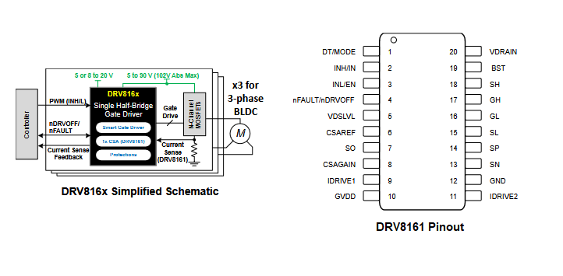

To understand how the DRV8161 operates, the functionality can be separated into two parts: **Phase Output** and **Hardware Selection and Fault Detection.**

**Phase Output**

The first key aspect of the DRV8161 is the actual generation of the Phase Signal through the various internal and external circuits of our motor driver. The DRV8161 motor driver operates by receiving a 12V supply voltage (GVDD) to power the chip. A PWM input signal is provided, where the high and low signals (INH/INL) control the gate driver. The input PWM signal interacts with the Dead Time/Mode (DT/MODE) configuration, determining the specific mode of operation for the driver. Based on this, the chip generates the necessary output signals: Bootstrap (BST), High-Side Gate (GH), High-Side Source (SH), Low-Side Gate (GL), and Low-Side Source (SL). These signals are then fed into the MOSFET circuits, which are responsible for switching and ultimately creating the motor's phase signals.

Additionally, the DRV8161 includes an integrated current sense amplifier to monitor the current flow through the MOSFETs. This feature provides an added layer of protection, helping to prevent overcurrent situations that could damage the MOSFETs or other components in the system. Through this sequence, the DRV8161 efficiently drives the motor while ensuring safe operation under varying load conditions.

**Hardware Selection and Fault Detection**

The second key aspect of the DRV8161’s operation is its integrated protection and hardware selection features. The chip allows users to configure various hardware settings through external resistors connected to specific pins. These pins include IDRIVE1, IDRIVE2, VDSLVL, and DT/MODE, each offering different levels of control for fault detection and functionality. The desired settings are selected by adjusting the resistors in the circuit around the DRV8161, and the choices made for this project will be detailed in a subsequent section.

In addition to these hardware selection options, the DRV8161 is equipped with several internal fault detection mechanisms, which are communicated through the nFAULT pin. This pin is pulled low during a fault condition, indicating issues such as GVDD undervoltage, VDS overcurrent, or thermal shutdown. With the help of a microcontroller monitoring these fault signals, the system can protect itself under these conditions. When a fault is detected, the chip disables the gate driver outputs, turning the external MOSFETs off to prevent further damage. Normal operation resumes only once the fault condition is cleared.

To better understand how the DRV8161 integrates into a complete system, let's now explore the PCB design process required to drive a 3-phase BLDC motor and enable its smooth operation.

***2.2.2.2. PCB Design and Creation***

**Understanding the Signals and Circuits Needed for Movement**

To begin designing the necessary PCBs for driving the motor, it's crucial to first understand the signals required for the operation of the 3-phase BLDC motor. The first step is identifying the motor’s pinout, which defines the signals needed for proper motor control. In this case, we focus on the NEMA 23 Hudston Servo Motor and its corresponding Molex Mini-Fit Jr. connector. This pinout provides key signal connections, such as phase signals and communication pins, that are essential for motor movement.

Table X: Pinout for the Molex Mini-Fit Jr. Pinout (Motor Pinout)

| **Pin #** | **AWG** | **Signal Name** | **Pin #** | **AWG** | **Signal Name** |
| --- | --- | --- | --- | --- | --- |
| 1 | 16 | P DRAIN | 2 | - | NO CONNECT |
| 3 | 26 | COMM S-T | 4 | 26 | COMM R-S |
| 5 | 26 | COMM T-R | 6 | 26 | E DRAIN |
| 7 | 26 | GND | 8 | 26 | ENC A~ |
| **9** | **16** | PHASE R | **10** | **16** | PHASE S |
| **11** | **16** | PHASE T | 12 | 26 | +5VDC IN |
| 13 | 26 | ENC I | 14 | 26 | ENC B |
| 15 | 26 | ENC A | 16 | 26 | ENC B~ |

Once the motor's pinout is understood, the next step is to examine the motor driver’s role in generating the required control signals. For this, we look at the DRV8161 Evaluation Module (EVM) paired with the LAUNCHXL-F280049C development kit. This combination of hardware, together with an external GUI on a laptop, enables the generation of PWM signals that drive the motor while also providing fault detection and diagnostics via built-in LEDs. Figure X below shows the different key areas involved in the operation of the EVM alongside the GUI.

Figure X: DRV8161 Evaluation Module’s Necessary Circuits and Signals

1. **PVDD/GND Input**: The power supply input and ground for the entire board, with an input voltage range of 4.5V to 48V and a maximum current rating of 30A.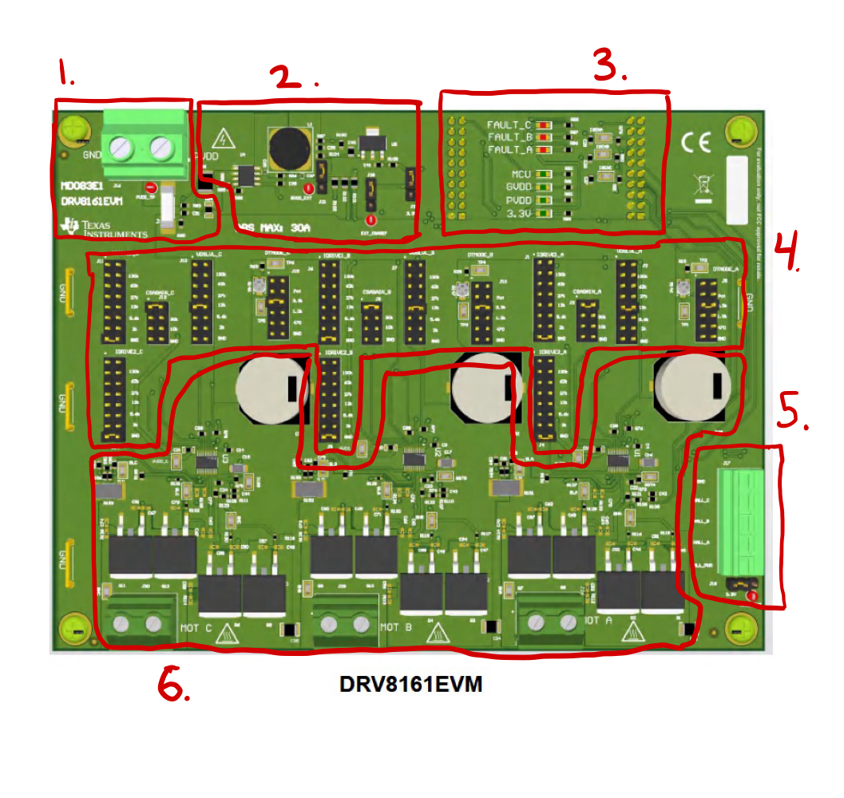
2. **12V and 3.3V Step-Down Circuits**: These circuits step down the input voltage to provide 12V GVDD for the motor driver and 3.3V for the CSAREF and MCU voltage requirements.
3. **Launchpad Integration and Fault/Status LEDs**: The LAUNCHXL-F280049C is mounted beneath the EVM and connected to a laptop via MicroUSB. The laptop interfaces with the GUI, which controls the MCU/EVM code and provides real-time fault and status monitoring via built-in LEDs.
4. **Hardware Configuration Jumpers**: Resistor jumpers allow for customization of the IDRIVE, CSA gain, VDSLVL, and dead time mode settings for each of the three DRV8161 motor drivers.
5. **Hall Sensor Inputs**: This feature takes input from an external Hall sensor in the motor, adjusting the phase outputs accordingly. These adjustments are made through the GUI for precise control.
6. **Motor Driver Circuits**: The EVM contains three identical motor driver circuits, each driving the phase signals generated by the DRV8161. Large terminals are provided at the bottom for routing the phase signal outputs.

Finally, we can categorize the critical and non-critical signals and circuits involved in driving the NEMA 23 motor using the DRV8161. **Critical signals and circuits** are essential for generating the phase outputs required by the motor drivers, such as the input voltages and Launchpad connections. **Non-critical signals and circuits**, on the other hand, are not strictly necessary for phase signal generation and can be configured to a fixed value, allowing for greater flexibility in PCB design. For example, the hardware selection signals can be set to a single, fixed value and do not need to be dynamically adjustable.

**Critical Signals and Circuits:**

* **PVDD/GND Input:** Supply power and GND to board. Used by almost everything on the board.
* **Launchpad Connection:** Launchpad connection jumpers to route signals generated by the GUI and the Launchpad to/from the Motor Drivers.
* **Hall Sensor Inputs:** Critical feedback mechanisms from the motor, allowing for accurate phase output adjustments.
* **Motor Phase Outputs:** The control phase signals generated by the DRV8161 Motor Driver, which control the rotation of the motor.
* **Step-Down Circuits:** 12V, 5V, and 3.3V step-down circuits are needed because of different components on the board.
* **Encoder Inputs:** Another critical feedback mechanism from the motor, allowing for precise control of movement from the motor.

**Non-Critical Signals and Circuits:**

* **Hardware Selection Jumpers (IDRIVE, CSA Gain, VDSLVL, DT Mode):** These signals are configurable through resistor combinations, but can be set to a fixed mode, eliminating the need for a dynamic adjustment jumper circuit.
* **Fault and Status LEDs:** Although non-critical, it is always helpful to have Fault and Status LEDs to help diagnose problems. Provides visual feedback from the MCU/Motor Driver to see faults.

With a clear understanding of the critical and non-critical signals required to drive the NEMA 23 motor using the DRV8161, we can now transition to the implementation of the system of three PCBs that were made to generate motor movement.

**Integrated PCB Design for Motor Operation**

The design and development of the PCBs were heavily inspired by the DRV8161 Evaluation Module, which provided a strong foundation for implementing the motor driver circuits. Many schematics, layout designs, and component footprint libraries required for the motor driver were readily available through Texas Instruments, streamlining the design process. Additionally, the voltage step-down circuits, an essential part of the PCBs, were adapted from schematics provided by Emily Hamsa, who is responsible for the Power Subsystem. Key elements such as the MOSFET layout and driver circuit designs drew direct inspiration from the DRV8161 EVM, ensuring both functionality and reliability. Below are some examples of the referenced schematics and layouts that influenced the PCB design.

Figure X: Motor Driver Schematics (Chip and Power Stage (Phase))

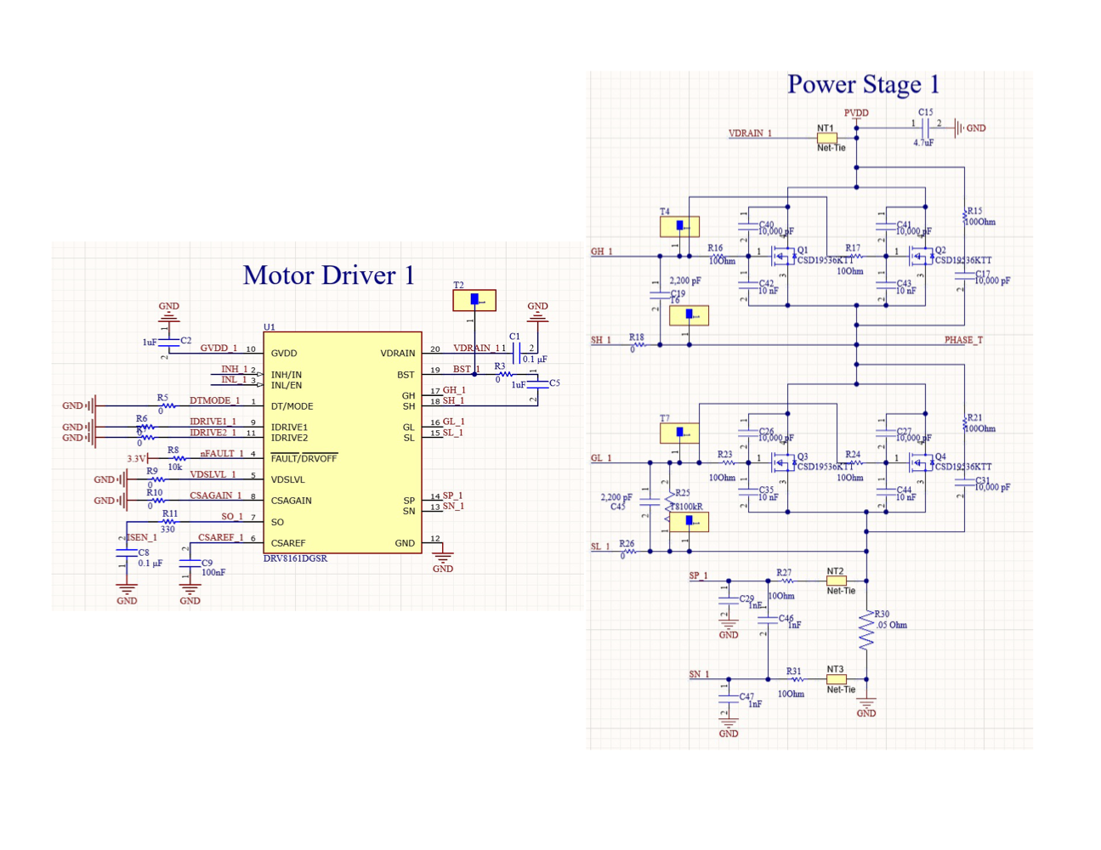

Figure X: MCU Launchpad Connector Schematic

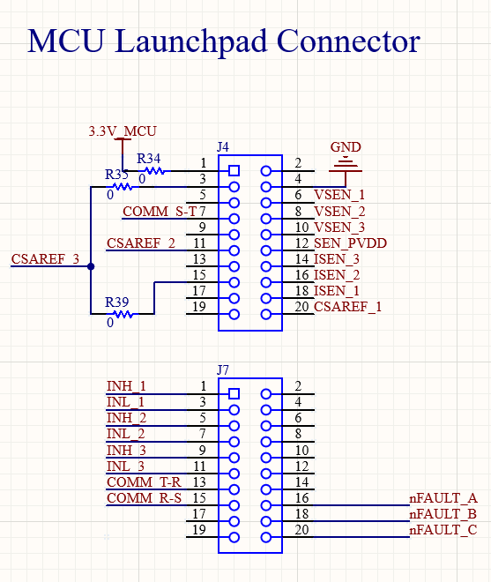

Figure X: Reference DRV8161 EVM PCB Layout

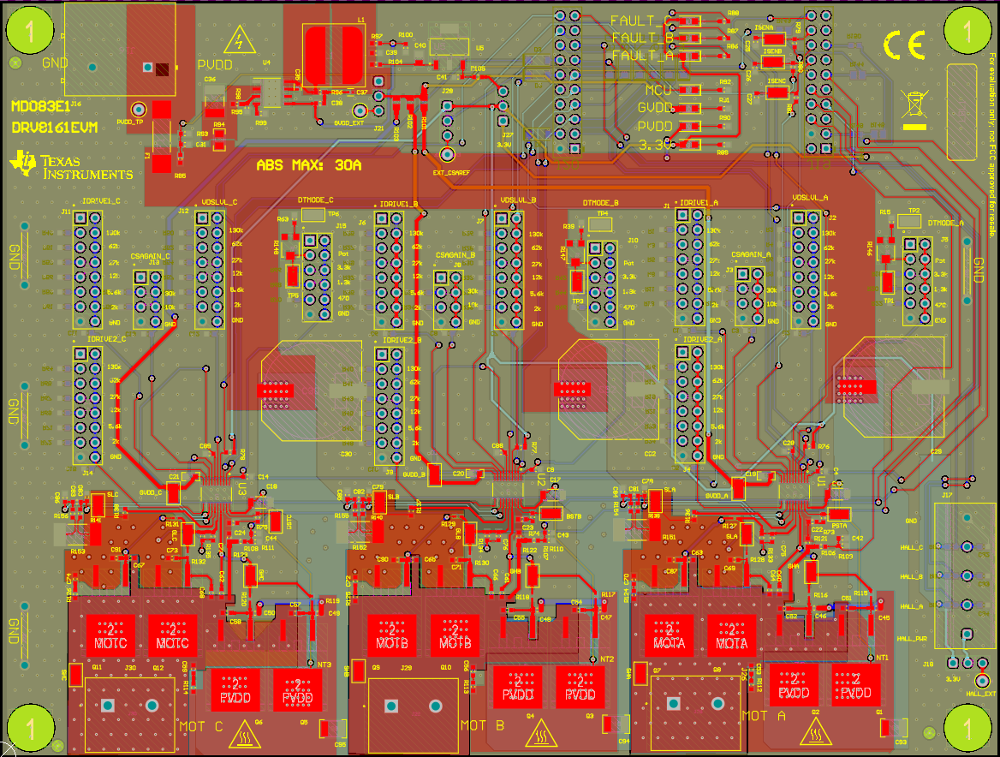

Above in Figure X, you can see the Hardware Selection jumpers for the different logic levels in the DRV8161 Motor Driver. Since this is a non-critical circuit in the creation of the phase signal, our boards were able to be simplified by setting each selection to its ‘Level 0’ logic level by having a 0Ω resistor for each selection. By setting the selection levels for each signal to its base value, we ensured that there would be no unexpected complications during operation and could omit the large circuitry needed for the resistance jumper selection system.

To finally generate motor movement using three DRV8161 Motor Drivers, a system of three PCB boards was developed: **Board A, Board B, and Board C**. Each board corresponds to one of the three phase signals required by the motor and produced by the motor drivers. Among these, Board A serves as the ‘Main Board,’ as it houses additional circuits necessary for the motor's operation. The other two boards, Board B and Board C, focus primarily on driving their respective phases. Below is a breakdown of each board, highlighting its key functionalities and the circuits it contains.

**Board A**

Board A serves as the ‘Main Board’ since it will be the main powerhouse of the three PCBs. It will serve as the board that the Launchpad and the motor will plug into and run off of. It will have output terminals for each of the step-down voltage circuits on the board, terminals for motor feedback functions, and terminals to input Motor Driver phase outputs from Boards B and C. Below are the key functions that are on the board:

Key Functions: **(Numbered in Figure X Below)**

* Take PVDD/GND Input (48V, 30A Input) **(1)**
* Motor Driver Circuit (Phase Generation) **(2)**
* Voltage Step-Down Circuits (Schematics from Emily Hamsa)
  + 48V PVDD -> 12V GVDD **(3a)**
  + 48V PVDD -> 5V Hall/Encoder **(3b)**
  + 48V PVDD -> 3.3V MCU **(3c)**
* Input Terminals for Phase B & C **(4)**
* LAUNCHXL-F280049C Jumper Connector **(5)**
* Input/Output Terminals for Encoder/Hall Sensor **(6)**
* Output Terminals for 12V, 5V, and 3.3V **(7)**
* Motor Connector Mating Terminal **(8)**

Board A was designed with the goal of isolating the ability to produce a single phase signal, making it straightforward to replicate this functionality across two additional boards—Board B and Board C. This modular approach simplifies the design process and ensures consistency between phases. Below is the completed build of Board A, labeled with its corresponding key functions as outlined above.

Figure X: Front and Back Implementation of the ‘Main Board’, Board A

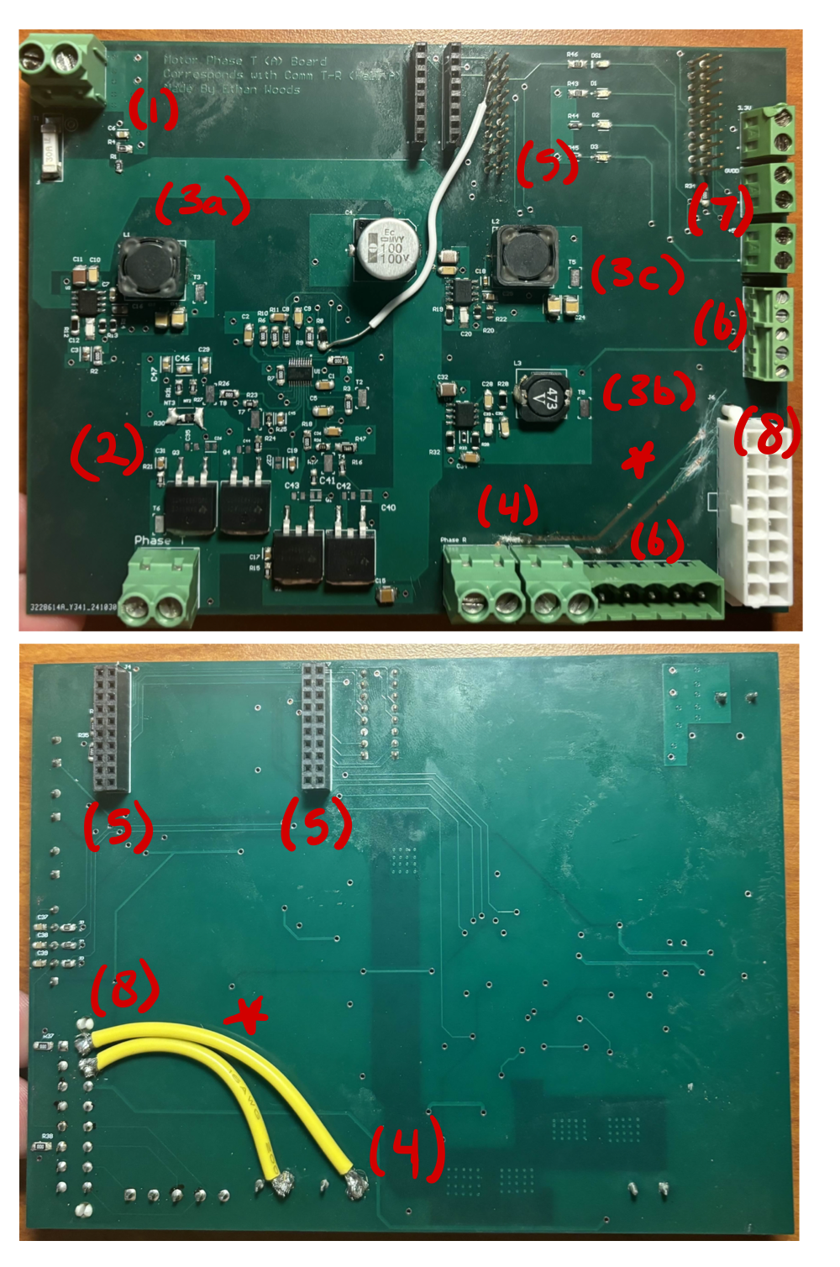

**Boards B & C**

Boards B and C complete the system by generating the final phase signals required to drive motor movement. These boards were intentionally designed for simplicity, relying solely on the signals provided by Board A to produce their respective phase outputs. Connections between Board A and Boards B and C are made via jumper wires, ensuring seamless communication. Once all necessary inputs are received, Boards B and C generate their corresponding phase signals, which are then routed back to Board A. Below are the key functions that are on the boards:

Key Functions: **(Numbered in Figure X Below)**

* PVDD/GND Input (48V, 30A Input) **(1)**
* Input Terminals for 12V and 3.3V **(2)**
* Jumper Terminals for Signals from Board A **(3)**
* Motor Driver Circuit (Phase Generation) **(4)**
* Phase Output Terminal **(5)**

Boards B and C are dedicated to generating their respective phase signals, which are then routed back to Board A for integration. This modular design allows each phase signal to be created independently, simplifying the overall system and ensuring flexibility in the design. Below are the finalized builds of Board B and Board C, with their key functions labeled as outlined above.

Figure X: Front and Back Implementation of Board B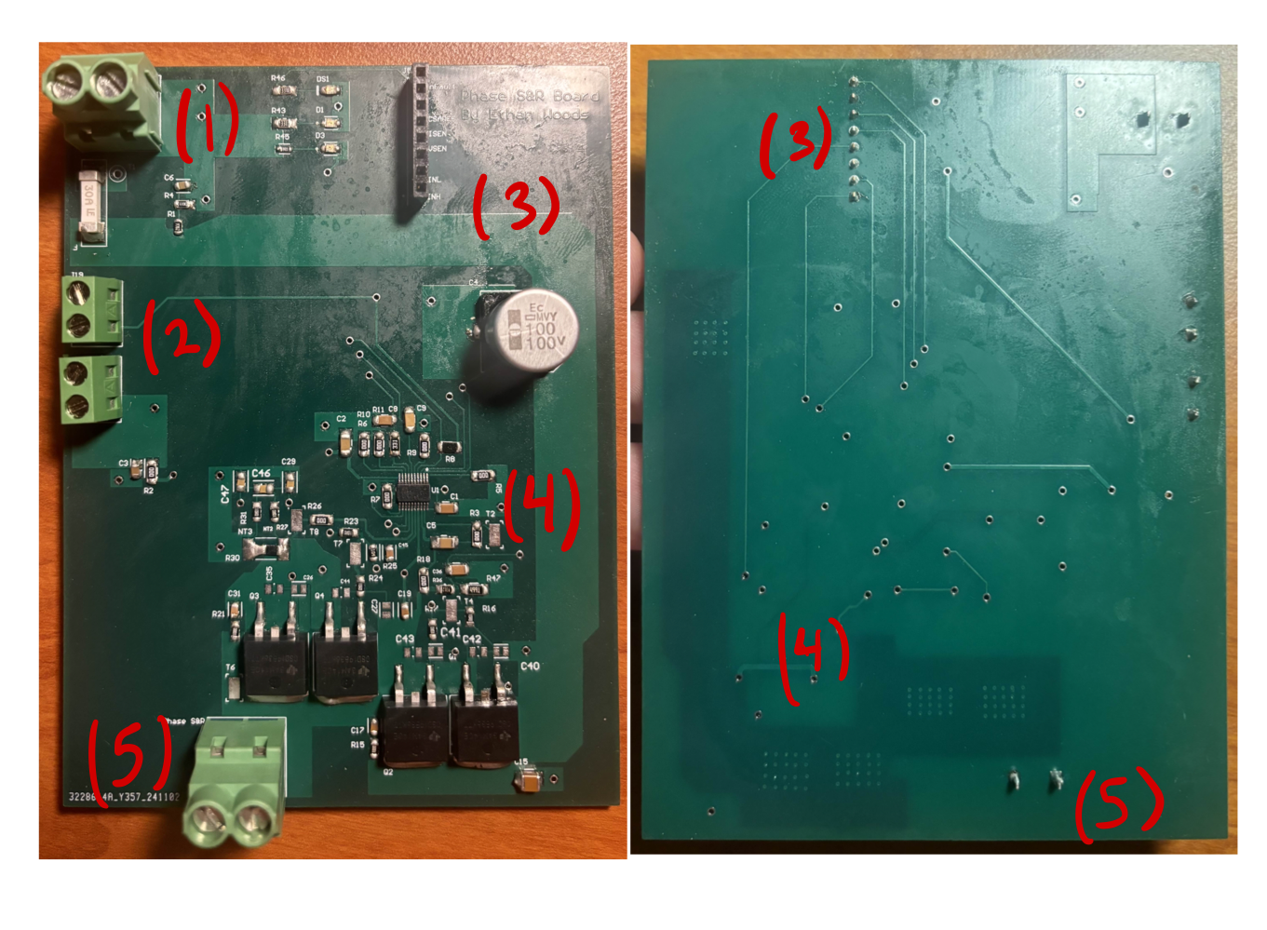

Figure X: Front and Back Implementation of Board C

With all three boards assembled and interconnected, the system is now ready to drive the motor. By connecting the Launchpad to the designated connector on Board A and linking it to a laptop, we can utilize the GUI software provided by Texas Instruments to control the setup. This GUI mirrors the functionality of the DRV8161 EVM, enabling the user to adjust parameters such as duty cycle and acceleration delay with ease. Through the GUI, the output of our PCB system can be enabled, allowing the generation of the phase signals required to drive the motor. Figure X shows the GUI and its configuration.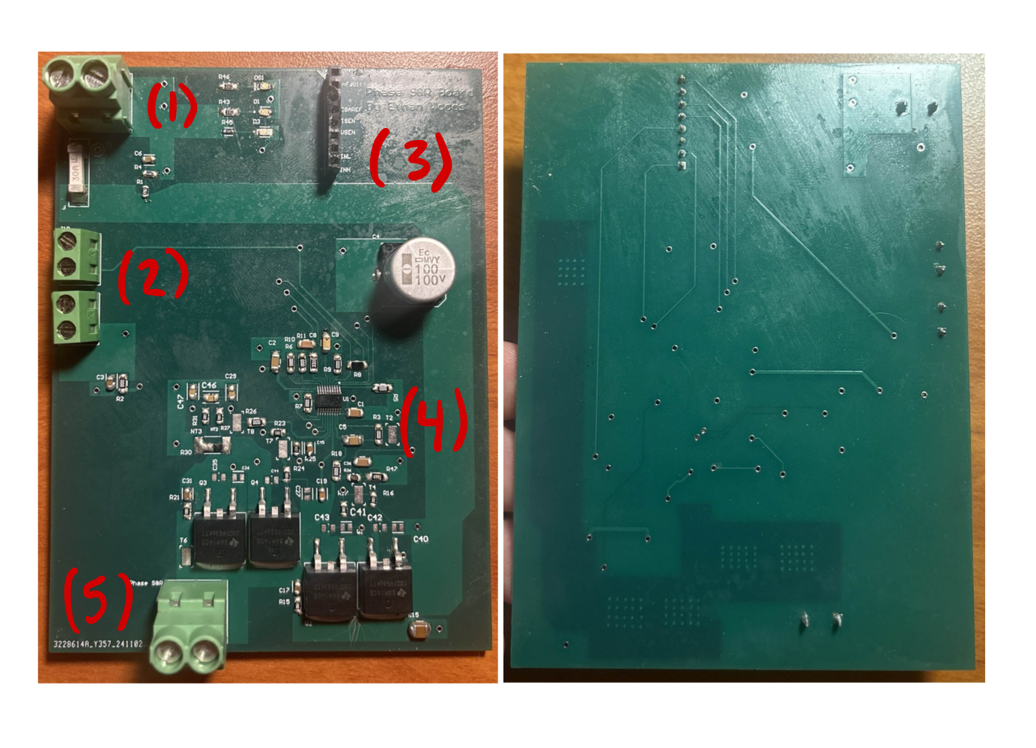

With the hardware and control system in place, we now move into **Testing and Results**, where we evaluate the performance and functionality of the PCBs in driving the motor.

Figure X: Texas Instruments DRV8161 Evaluation Module GUI

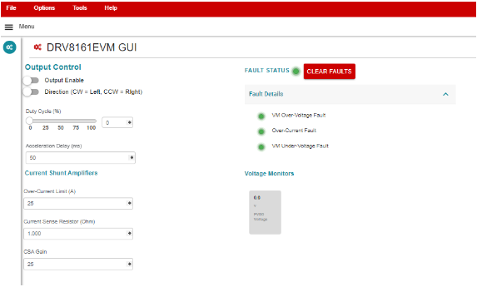

***2.2.2.3. Testing and Results***

To begin testing each board, we started by powering them using a 48V 25A power supply. On power-up, the corresponding LEDs on Board A illuminated as expected, confirming proper functionality. However, on Boards B and C, some LEDs were found to be installed backward, preventing them from lighting even when power was applied. Despite this, terminal testing with a multimeter confirmed that all PVDD and GND connections were functioning correctly, ensuring the boards were receiving power.

With power delivery confirmed, the next step was to validate the functionality of the DRV8161 EVM as a baseline for comparison. The EVM was powered using the same 48V 25A power supply and connected to the GUI through the LAUNCHXL-F280049C Launchpad. This setup allowed us to simulate identical circuit conditions to those in our PCB system and measure the phase output voltages generated by the EVM.

To verify the performance of our boards, the phase output voltages from the DRV8161 EVM were measured and used as reference values. By comparing these outputs with the corresponding phase signals from our boards, we could validate whether the PCB system was producing accurate signals needed for motor operation.

Below is the process for connecting and measuring the outputs from the DRV8161 EVM, followed by images of the measured phase signals for comparison.

Figure X: DRV8161 EVM Connected to Power Supply and Launchpad

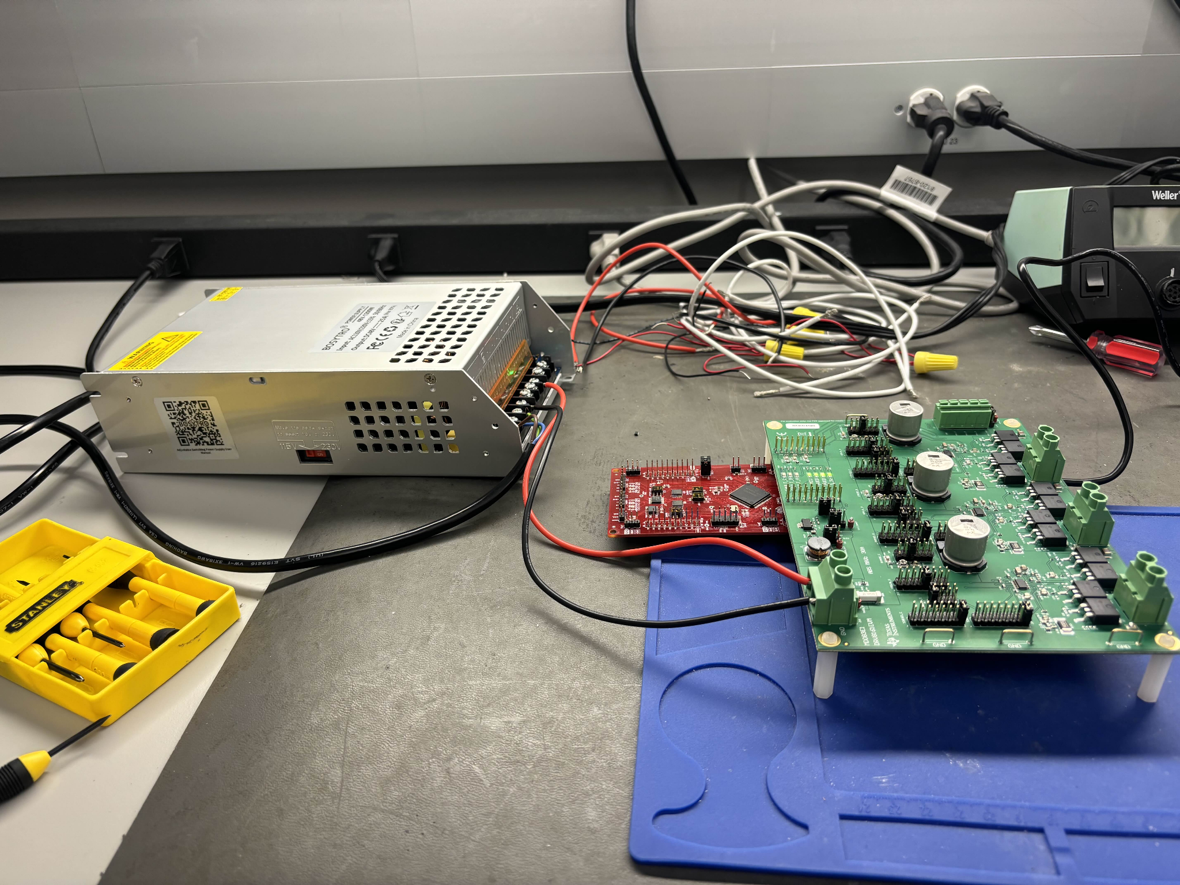

Figure X: GUI Interface Showing Connection to 48V PVDD with Output Disabled

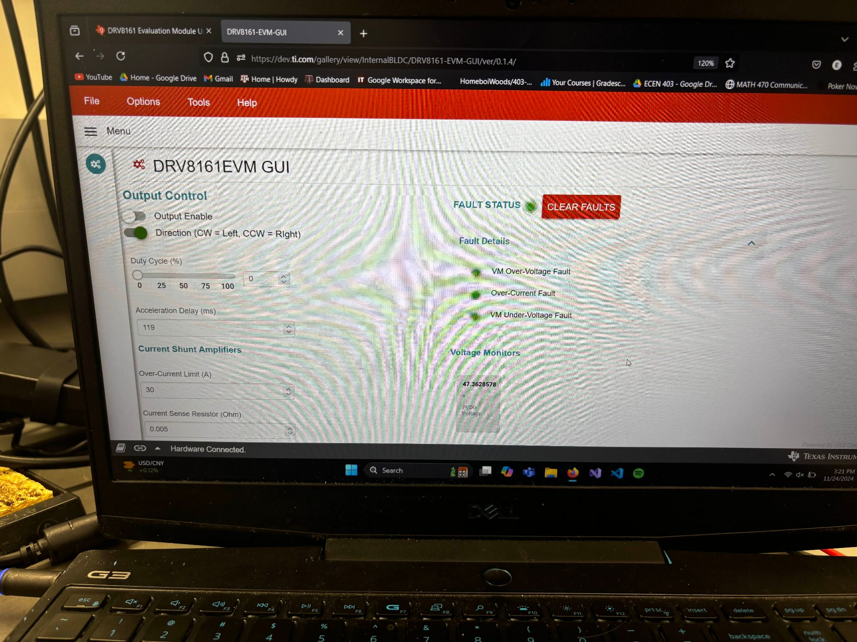

Once connected, the DRV8161 EVM is successfully linked to the Launchpad and ready to enable its output to produce the three-phase signals required for motor operation. However, while the EVM can generate these signals, we are unable to use it to spin a motor directly due to the design of Board A.

Although Board A includes terminals capable of routing all three-phase signals to the motor connector, this setup is incompatible with the motor driver already present on Board A. Since the motor driver circuit is powered through the board's power supply, it interferes with the output at one of the terminals used to route a phase signal. As a result, the motor cannot be properly connected or controlled via Board A when paired with the EVM.

Instead, validation is performed by comparing the phase output voltages at the EVM's phase terminals with those generated by our PCBs. By measuring and analyzing these outputs, we can confirm the functionality of our design. Below are the results of measuring the phase output terminals for each respective phase.

Figure X: Measuring the Phase Output Terminal on the DRV8161 EVM

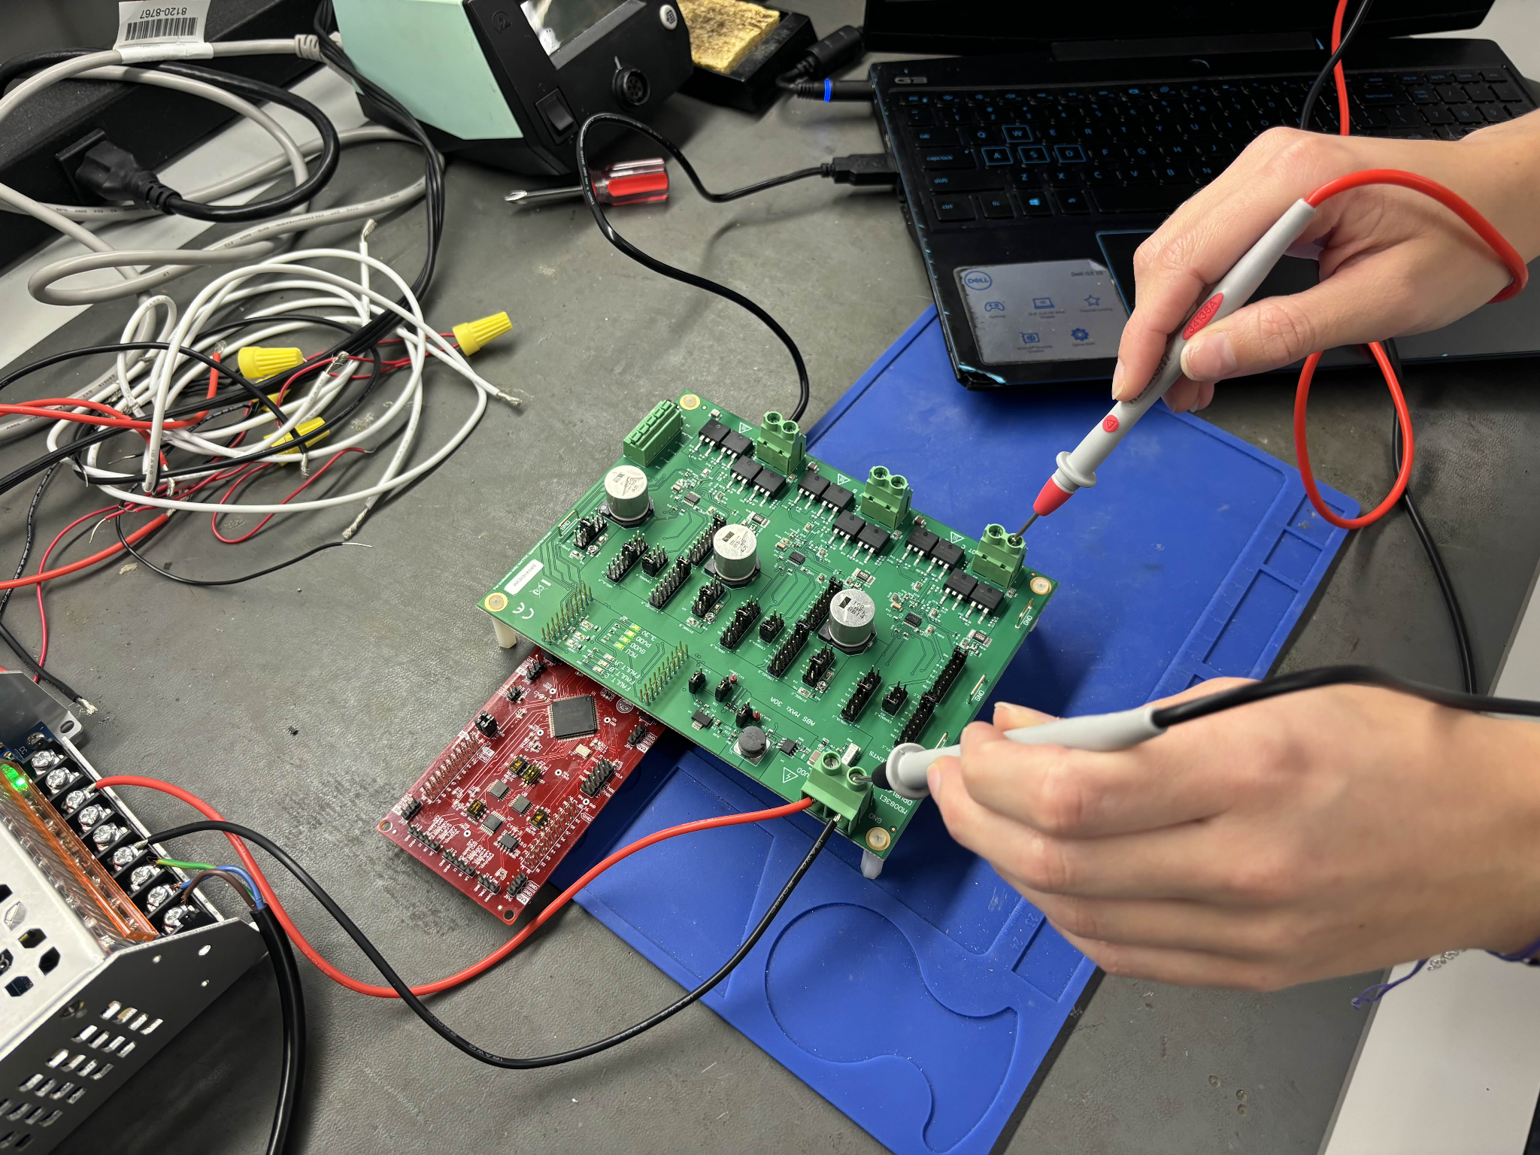

Figure X: Phase Voltage Outputs on Terminals A, B, and C (Respectively)

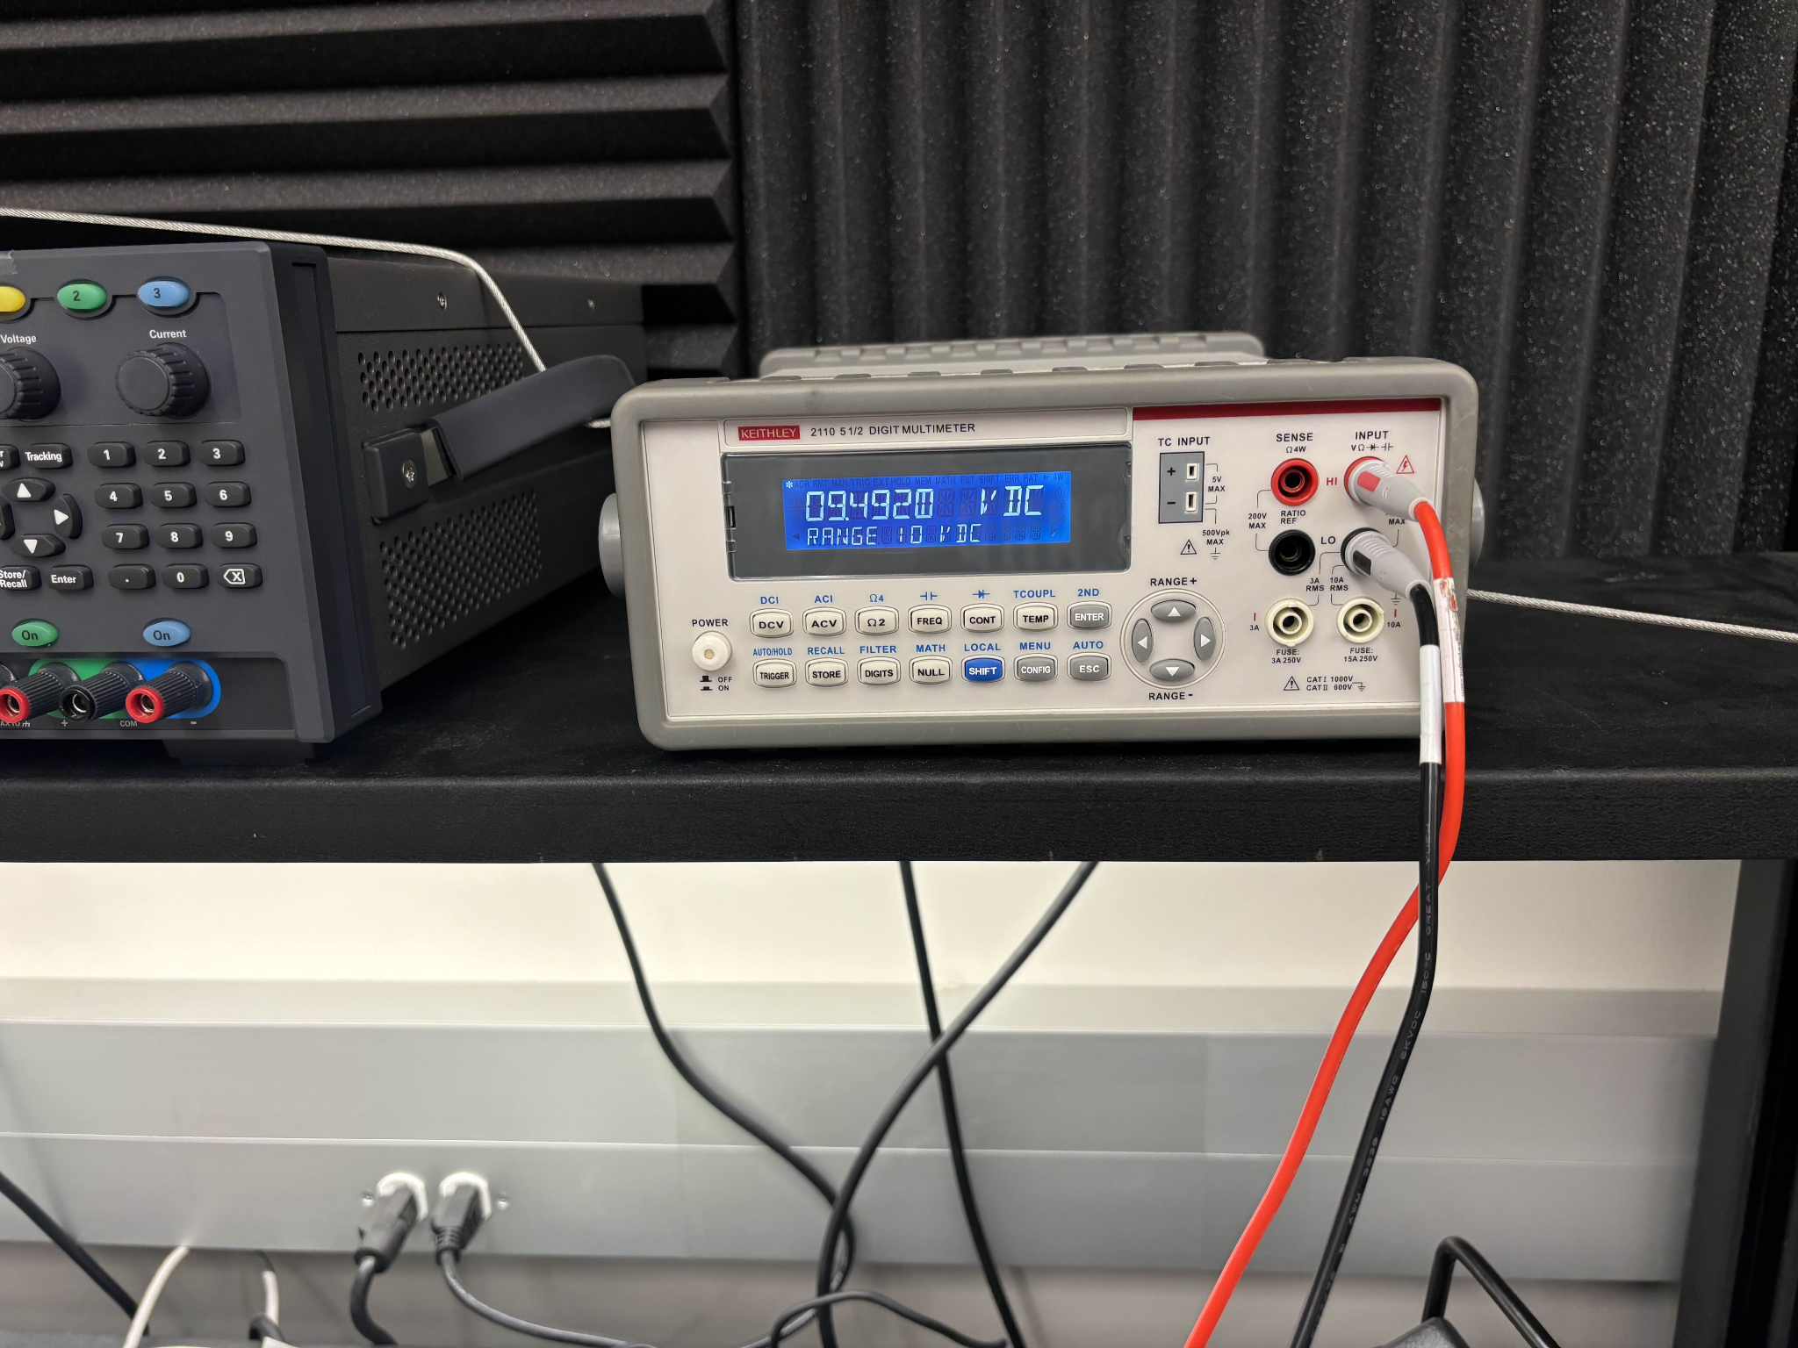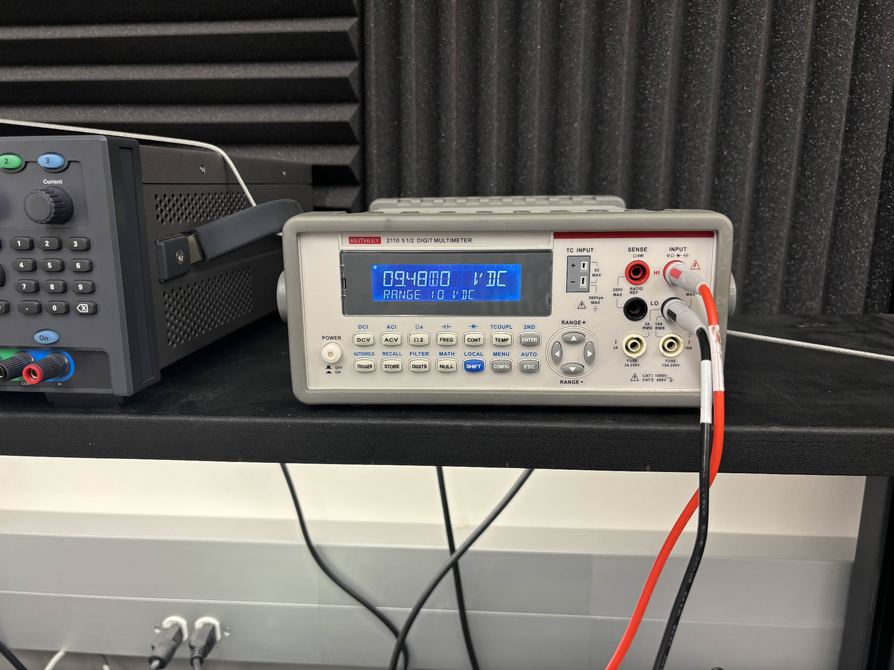

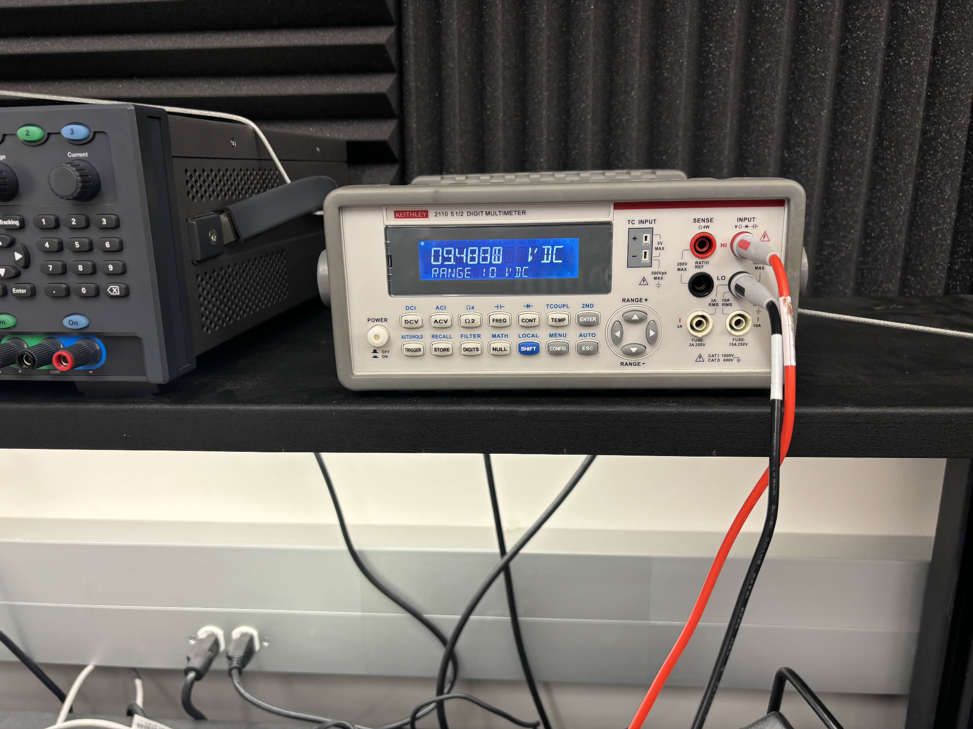

As seen in Figure X, the three-phase output terminals of the DRV8161 EVM measure approximately 9.48 Volts. This voltage serves as the benchmark for validating the outputs of our PCB system. To begin testing the three PCBs, the boards are connected as shown in Figure X below.

Figure X: Created PCBs All Wired Together Without Motor and Phases Connected

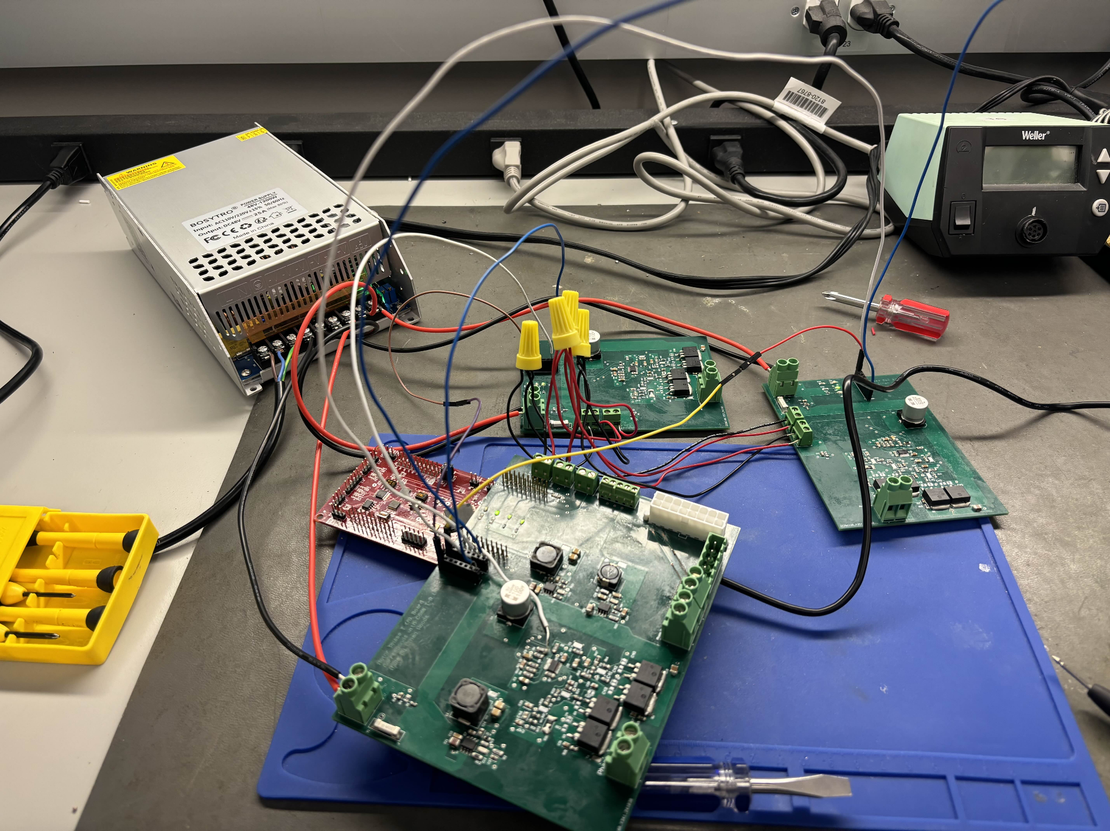

In this setup, all the boards are powered by the 48V power supply, and the necessary input signals for generating the phases are routed accordingly. However, as depicted in Figure X, the motor and phase signal connections to Board A are not included in this particular configuration.

Earlier in the day, during an initial test with the motor and phase wires connected, enabling the output via the GUI resulted in a trace on Board A burning out instantly. Despite debugging and reattempting, the same issue occurred a second time. The damaged trace was subsequently repaired with a replacement wire, as shown in the previously referenced Figure X (denoted by the star).

Given this outcome, testing now focuses on measuring the voltage outputs at the phase terminals and verifying the functionality of the voltage step-down circuits. The results of these measurements are detailed in the following figures:

Figure X: Successful Connection to the GUI Showing 48V PVDD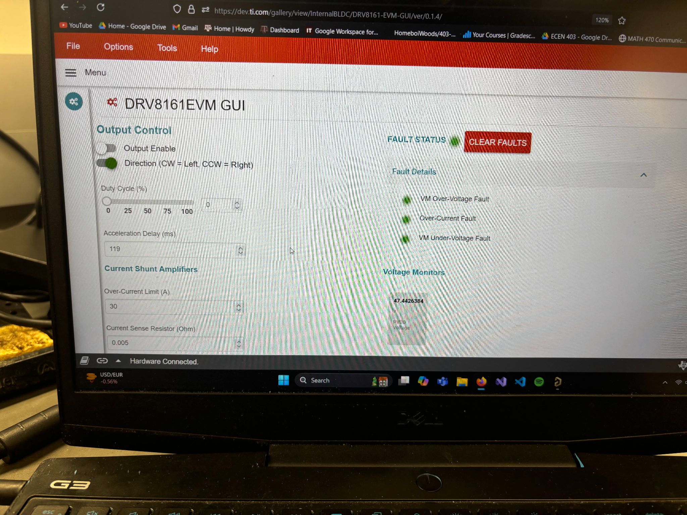

Figure X: Output of Each Voltage Step-Down Circuit (3.3V, 5V, and 12V Respectively)

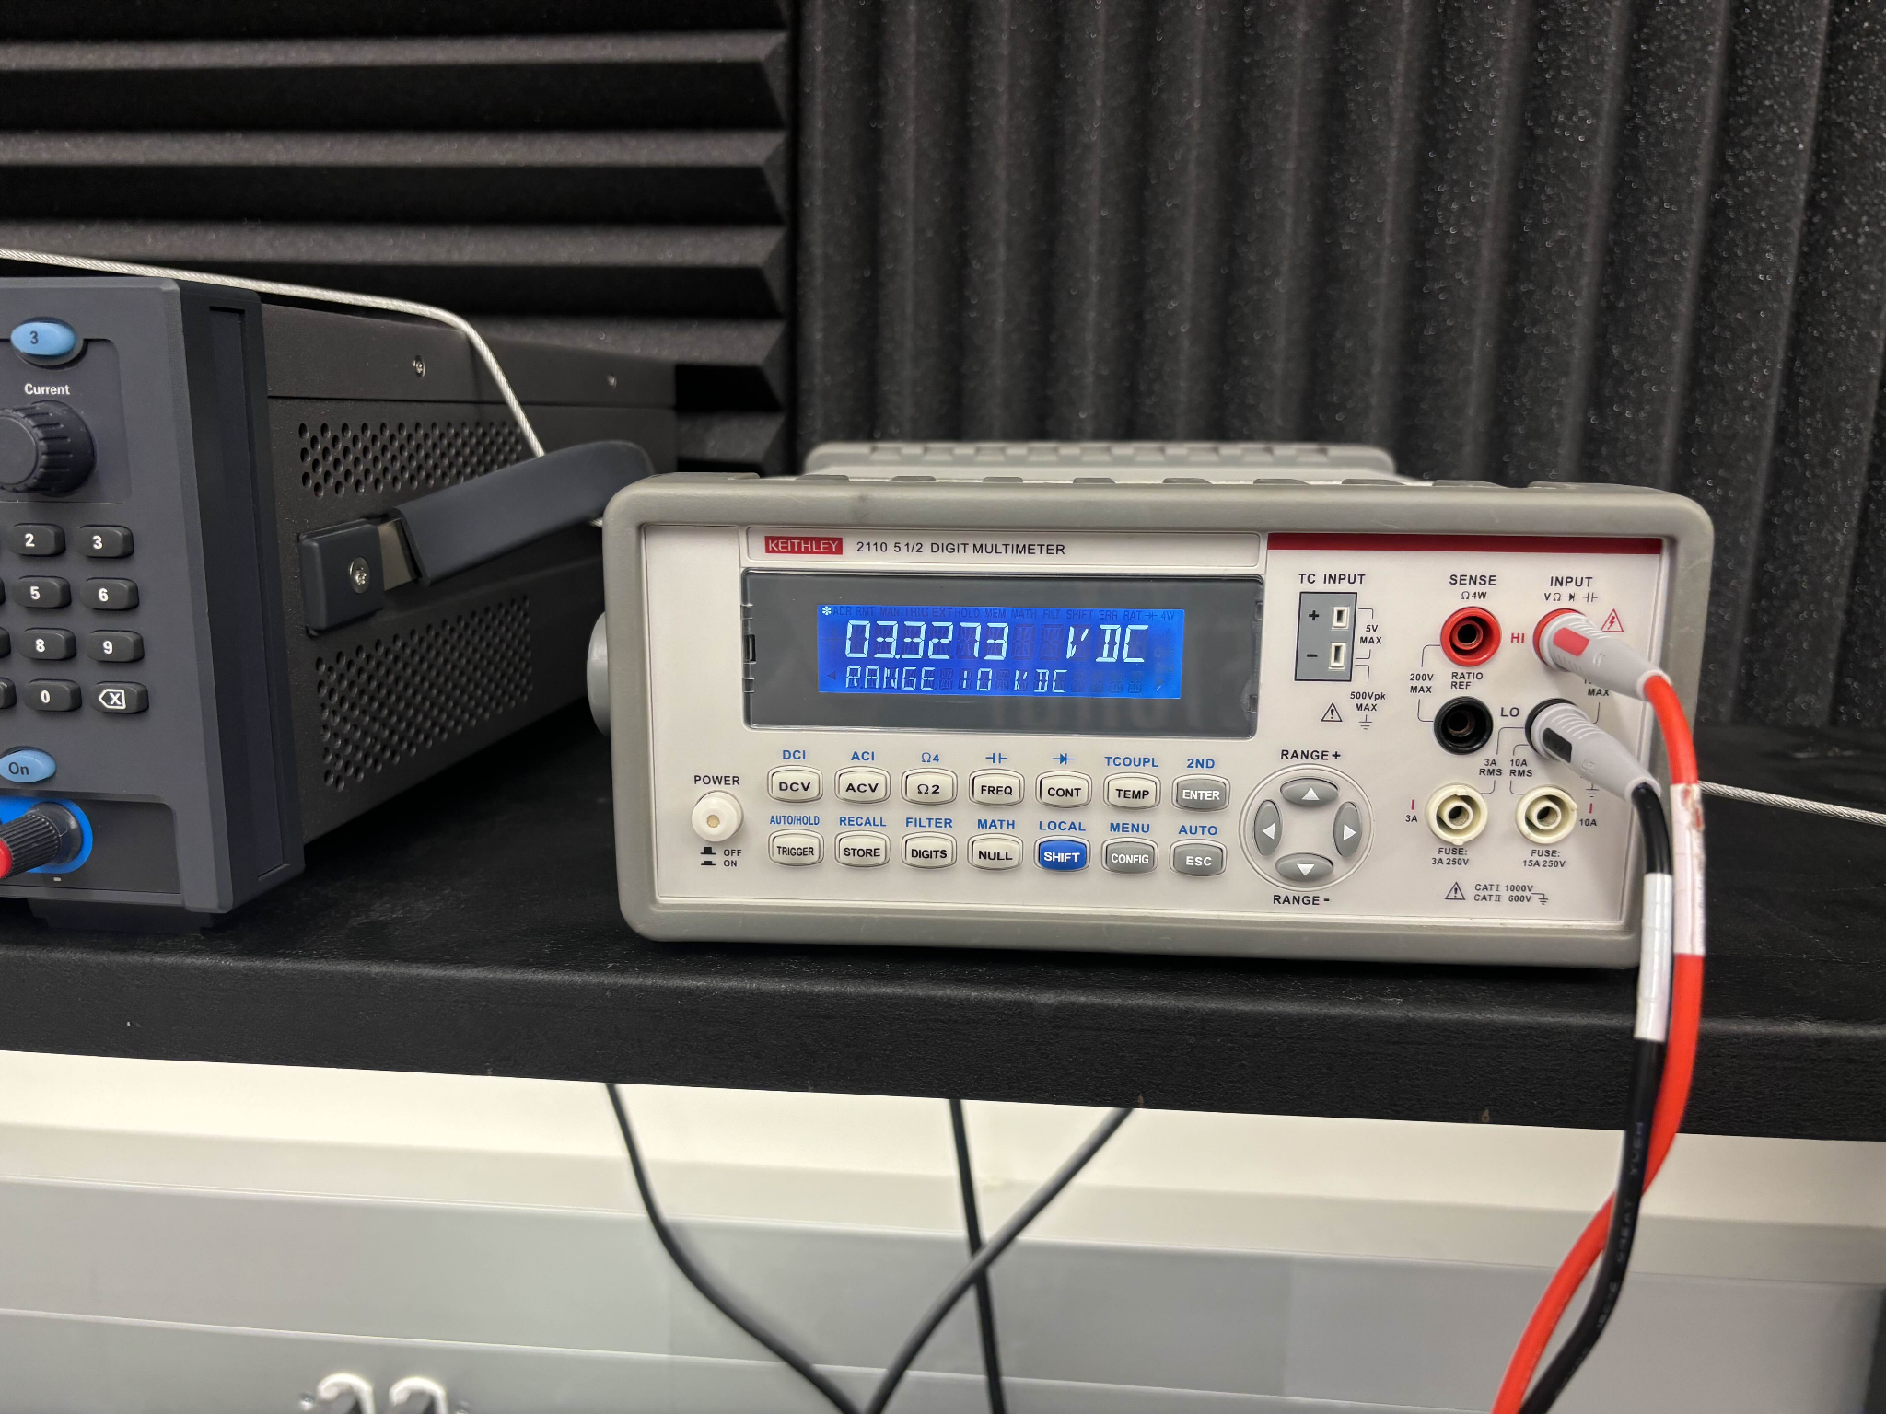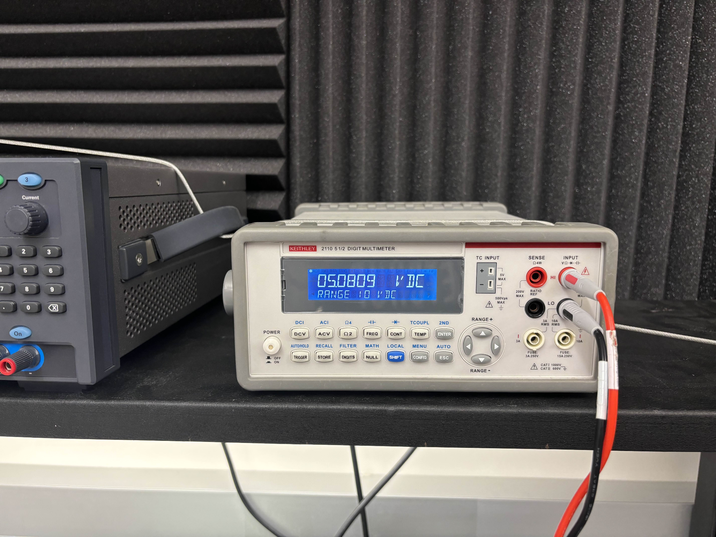

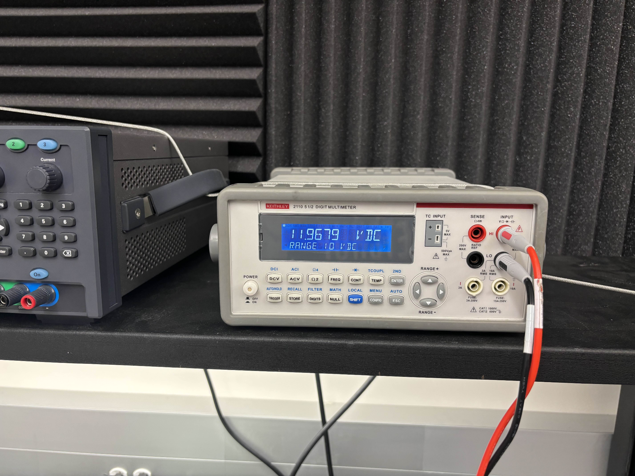

Figure X: Measuring the Phase Output Terminal on Phase A Board (Same for B and C)

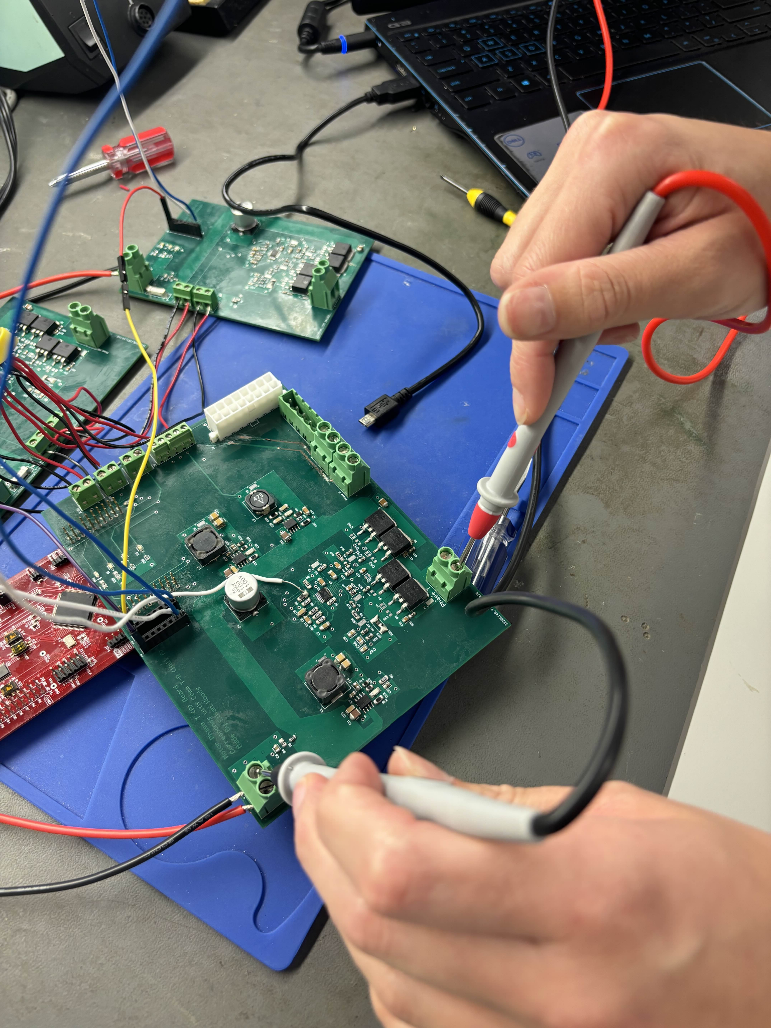

Figure X: Phase Voltage Output on Each Board (A, B, C) Respectively

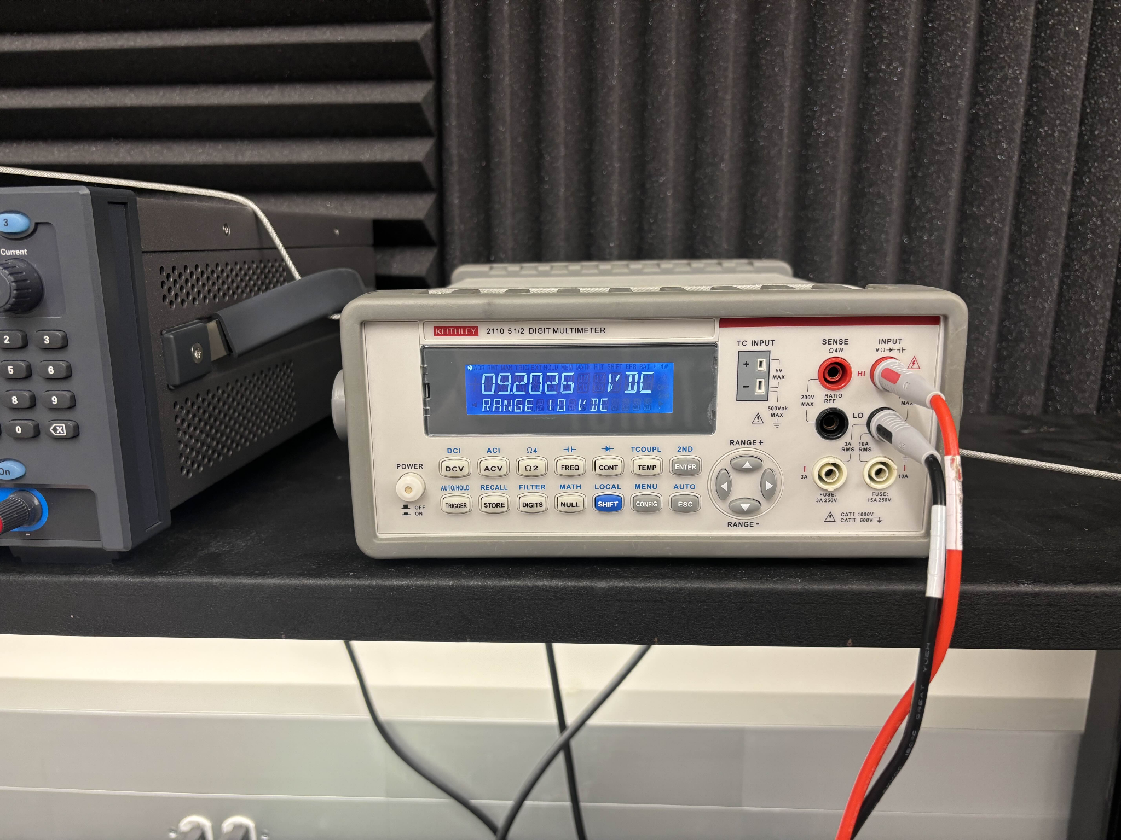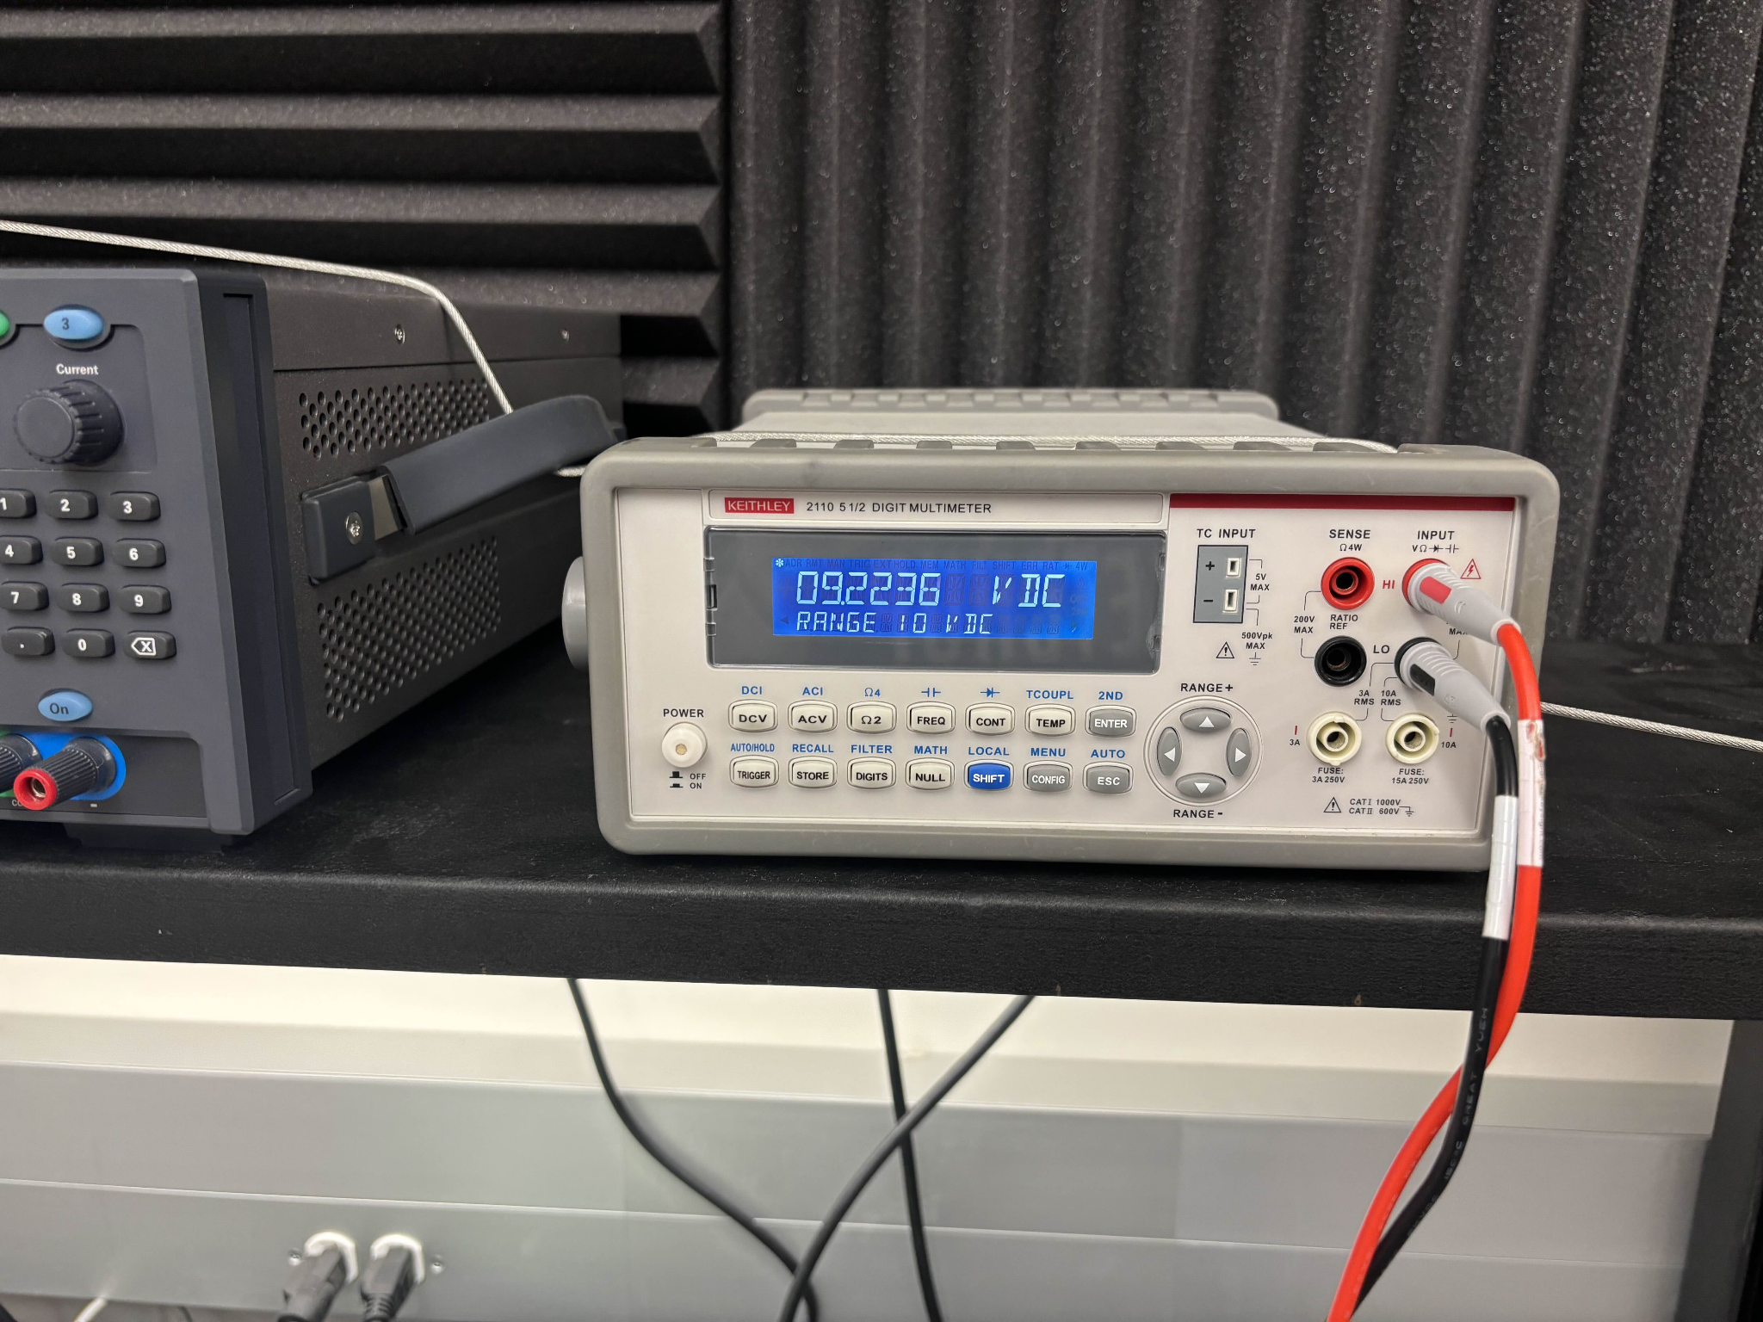

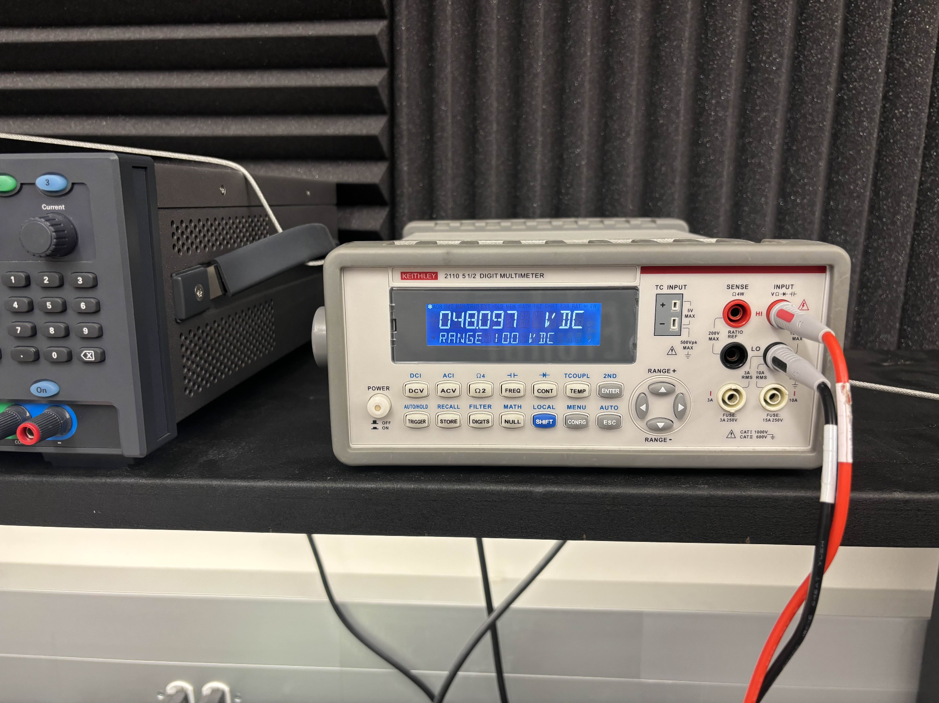

In conclusion, while the testing of the PCB system did not achieve the desired outcome of motor movement, significant progress was made in understanding and isolating the issues. The measurement results confirmed that two of the phase terminals (A and B) were functioning as expected, producing voltages near 9.48V. However, the issue with Board C, where one of the terminals was producing an unexpected 48V, highlighted a short to the input voltage. This has been traced back to a potential fault with the DRV8161 chip, which will be further investigated.

Given the importance of having all three motor driver circuits fully functional, Board C's failure prevents the successful operation of the 3-phase BLDC motor. However, with plans for continued work over the winter break, efforts will focus on reworking Board C and potentially creating an additional board to ensure proper motor operation. Though this semester’s testing did not achieve the final goal, it laid the critical groundwork needed for future progress.

Looking ahead, further testing and refinement will be necessary to achieve full motor movement and integration with other subsystems in ECEN 404. The experience gained this semester will prove invaluable as we continue to improve the design, and the validation of the system’s objectives will be a crucial next step in confirming the success of the overall project.

***2.3. Subsystem Validation***

The ultimate goal of validating this subsystem was to achieve movement in a 3-Phase BLDC Motor using a system of custom PCBs connected to the C2000 Launchpad. While motor movement was not achieved this semester due to a short on one of the boards, the validation focuses on proving that generating one correct phase signal demonstrates the feasibility of producing the other two in the same manner. This reasoning underscores the importance of achieving even partial functionality, as it lays the groundwork for future success.

Given the complexity of this subsystem, involving over 200 components (primarily 0805-sized) across multiple PCBs, there were many opportunities for small errors to propagate and affect overall performance. Each board required meticulous attention to detail, from schematic design to fabrication and testing, to ensure proper operation. Therefore, the validation approach breaks down the subsystem into measurable, incremental goals to assess the progress made and identify areas for improvement.

Below is the validation plan, highlighting the specific criteria used to evaluate each aspect of the subsystem and how it aligns with the project’s objectives:

Table X: Motor Driver Subsystem Validation Plan Goals

| **Test Deliverable** | **Achieved Goal?** | **Why/How?** | **Supporting Figure** |
| --- | --- | --- | --- |
| **Schematic and PCB Design** | Yes | Created system of 3 PCBs to work to spin a motor | Figure X |
| **PWM Phase Output from Motor Drivers** | Yes | Achieved an output voltage similar to our benchmark voltage on the EVM | Figure X |
| **Motor Movement** | No | Short on Board C prevented complete integration and motor movement | Figure X |
| **Precise Motor Control** | No | With no motor movement, no control could be done | N/A |
| **All Motor Movement** | No | No motor movement generated | N/A |

***2.4. Subsystem Conclusion***

While motor movement remains unachieved this semester, significant groundwork has been laid to make it an attainable goal in the near future. This is a critical step for the Collaborative Robot, as motor-driven movement is central to its functionality. Despite this gap, the process and implementation described show that motor movement is within reach. The priority for the winter break will be to repair or produce a new board to replace the malfunctioning Board C. With a functioning Board C—or an alternative board designed to fulfill its role—motor movement should be straightforward, requiring only connection to the GUI and Launchpad.

Beyond this immediate task, the Motor/Motor Movement subsystem is well-positioned to transition into the next phase of integration. The current approach, using three motor drivers to spin a 3-Phase BLDC motor, will remain the foundation moving forward. However, next semester’s design will consolidate the motor driver circuits onto a single main board, which will simplify wiring and reduce the overall complexity of the system. This main board will interface with a dedicated voltage step-down board from the Power Subsystem, streamlining power distribution. Custom connectors for each motor will also ensure proper compatibility and ease of use.

This brings us to a key consideration: complexity. Creating and testing these initial boards, which only include the minimum functionality to generate phase signals, required designing over 200 components. Scaling this approach to accommodate four additional motors would demand an immense amount of time and effort, which is further compounded by the limited resources and lack of mechanical engineering expertise within the team. As a result, there is growing support for simplifying the collaborative robot into a crane-like design. This shift would reduce the motor count from four to two (plus a claw), cutting the number of required boards in half and allowing the team to focus on optimizing the system’s core functions.

Despite these challenges, the subsystem’s achievements this semester provide a solid foundation for future work. With phase signals successfully generated and the boards communicating effectively with the MCU subsystem, integration is already underway. Next semester, the focus will include refining the PWM signals needed to drive the motor driver circuits, collaborating with the Power Subsystem to route external voltage levels directly onto the main board, and enhancing interaction with the Wireless Connectivity Subsystem for mobile application control. This forward-looking plan ensures that, with continued effort, the Motor/Motor Movement subsystem will achieve full functionality and play a pivotal role in the Collaborative Robot’s success.

# MCU/Processing Subsystem

## 3.1. Subsystem Introduction

The MCU/Processing subsystem is designed to receive input signals from the mobile application subsystem and generate PWM waveforms that will be used by the motor driver subsystem to control a motor. This subsystem utilizes the TMS320F280049C microcontroller from Texas Instruments’ C2000 family of real-time control MCUs. The power subsystem supplies the necessary power to the MCU to facilitate the completion of tasks. The MCU subsystem has been designed to incorporate compatibility and integration to other subsystems. The required deliverables of this subsystem have been accomplished by adhering to the execution and validation plan. Furthermore, the subsystem was thoroughly tested in the lab to ensure the necessary signals can be received and generated to achieve the end project goal. The following documentation provides a detailed breakdown as to what has been accomplished.

## 3.2. Subsystem Details

### 3.2.1 Subsystem Block Diagram

The following figure presents a high level block diagram for the MCU/Processing Subsystem, which is capable of receiving signals from the ESP-32 and generating PWM signals for motor control.

Figure X: MCU/Processing Block Diagram

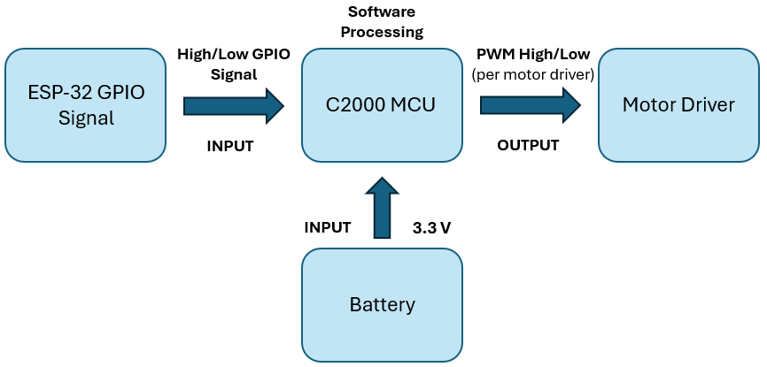

The MCU/Processing subsystem utilizes the TMS320F280049C MCU, which features a variety of peripherals such as pulse-width modulation (PWM) for motor control and a large quantity of General-Purpose Input/Output (GPIO) pins. The GPIO pins will support the communication between the C2000 and the ESP-32 within the mobile application subsystem.

The mobile application subsystem includes a mobile app with a game style like controller. When a button is pressed, a GPIO pin on the ESP-32 shall change from low to high. The C2000 will detect this input and generate the necessary PWM signals. These PWM signals will be sent to the DRV816x motor drivers to rotate a Brushless DC motor (BLDC).

### 3.2.2. PCB Schematic Design

The primary objective for the MCU/Processing subsystem was to design a PCB that enables functionality of the MCU, including power to the MCU, programming via JTAG, generating PWM signals, establishing communication with external devices like the ESP-32, and verifying GPIO functionality. Key features of the MCU include its 3.3V operating voltage, 16 ePWM channels, and 40 GPIO pins.

The PCB was built with reference from the C2000 Launchpad development board, an evaluation board that TI created to incorporate the TMS320F280049C MCU for developmental purposes. The following sections of the document detail the design of the PCB which focuses on GPIO allocation, Power, Programming, and Miscellaneous parts.

#### 3.2.2.1. General-Purpose Input/Output (GPIO)

The figure below details the GPIO allocation within the PCB schematic.

Figure X: GPIO PCB Schematic

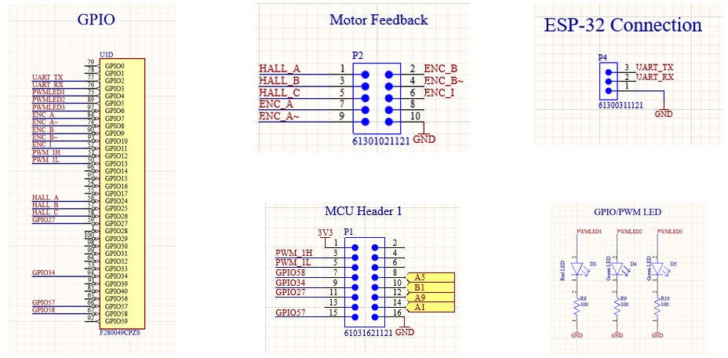

The GPIO pins contain specific features, pins with the ability to generate PWM signals and additional GPIO functionality were considered when deciding what pins to implement to headers. In the next PCB revision, all the GPIO pins from the MCU will be routed to 2.54mm x 2.54mm headers. The first 16x pins (GPIO0-GPIO15) include the 16x ePWM modules and will be reserved solely for PWM generation. The MCU contains 35 accessible GPIO pins, 19 of which are used in the current PCB design. These pins allow testing of the ePWM modules and generic input/output writing to GPIOs.

In the above figure, GPIO pins 2 - 13 were used to develop PWM signals for the motor driver subsystem. Additionally, these pins were used to toggle LEDs, showcasing GPIO functionality and timing, as well as rotate servo and stepper motors. The additional GPIO pins were used to connect the ESP-32 and C2000 to communicate through high/low signal generation.

One BLDC motor requires three motor drivers, one motor driver for each phase of the motor. Each motor driver will receive a high and low PWM signal, a fault check signal, and reference voltage. The below table showcases the necessary signals to be sent from the MCU to three motor drivers. The signals include PWM generation, fault check, and reference voltage.

Table X: C2000 Pinout (Signals sent to 3x Motor Drivers)

| Pin Number | Signal Name | Description | Purpose |
| --- | --- | --- | --- |
| 79 | GPIO0 | ePWM-1 Output A | High PWM |
| 78 | GPIO1 | ePWM-1 Output B | Low PWM |
| 77 | GPIO2 | ePWM-2 Output A | High PWM |
| 76 | GPIO3 | ePWM-2 Output B | Low PWM |
| 75 | GPIO4 | ePWM-3 Output A | High PWM |
| 89 | GPIO5 | ePWM-3 Output B | Low PWM |
| 98 | GPIO30 | General I/O 30 | Fault Check |
| 99 | GPIO31 | General I/O 31 | Fault Check |
| 64 | GPIO32 | General I/O 32 | Fault Check |
| 23 | A0 | DAC-A Output | Reference Voltage |
| - | 3V3 | Reference Voltage | Reference Voltage |

The below table dictates the pinout between the C2000 and ESP-32. Although testing was not performed with these exact GPIO pins, other general-purpose pins were used. This table is to map out the future of what will be required. The purpose of these connections is to establish communication between the ESP-32 and C2000. The ESP-32 will toggle pins high or low based on user input to the mobile application. The C2000 will read input on the GPIO pins below to determine the desired movement from the user and generate the subsequent PWM signals.

Table X: C2000 Pinout for ESP-32 Connectivity

| Pin Number | Signal Name | Description | Purpose |
| --- | --- | --- | --- |
| 56 | GPIO24 | General-Purpose Input Output 24 | UP |
| 57 | GPIO25 | General-Purpose Input Output 25 | DOWN |
| 58 | GPIO26 | General-Purpose Input Output 26 | LEFT |
| 59 | GPIO27 | General-Purpose Input Output 27 | RIGHT |
| 1 | GPIO28 | General-Purpose Input Output 28 | OPEN |
| 100 | GPIO29 | General-Purpose Input Output 29 | CLOSE |

#### 3.2.2.2. Power

This section details the power design for the MCU. The MCU operates at 3.3V, which is supplied through the terminal block and will allow integration with the power subsystem. To maintain stable voltage, decoupling capacitors on the VDD, VDDA, and VDDIO pins were placed with values of 0.1uF, 10uF, and 2.2uF. Additionally, power indicator LEDs were included to display when the system is powered.

Figure X: Power PCB Schematic

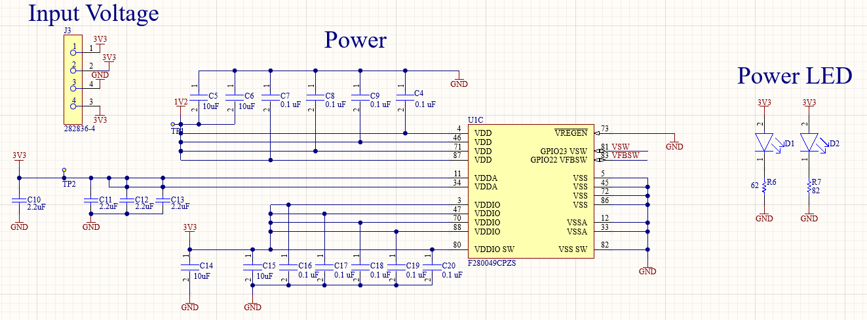

#### 3.2.2.3. Programming (JTAG)

This section details the schematic design for programming via JTAG. The programming process requires the TMS, TDI, TDO, and TCK signals. Due to sponsor uncertainty and concerns with connectivity to the debug probe, two headers were incorporated into the design: J2 (6 pin 2.54mm x 2.54mm) and J1 (14 pin 1.27mm x 1.27mm). However, J1 was ultimately unused due to connection issues with the XDS-110 debug probe.

Figure X: JTAG Programming PCB Schematic

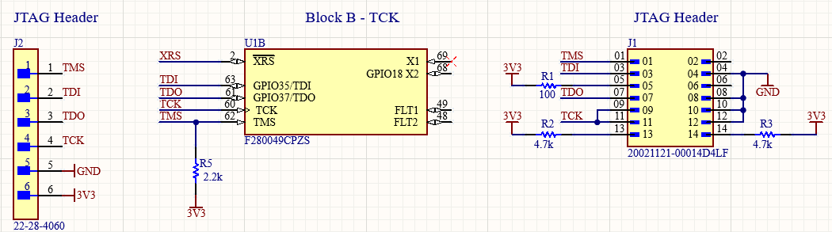

**3.2.2.4. Miscellaneous**

This section outlines miscellaneous components of the PCB that were ultimately unused. The figure below highlights the ADC block, reset button, launchpad input, VSW input, and launchpad LED input. Throughout the semester, it became clear that these components were unnecessary and will be removed for the next generation design planned for next semester.

Figure X: Miscellaneous PCB Schematic

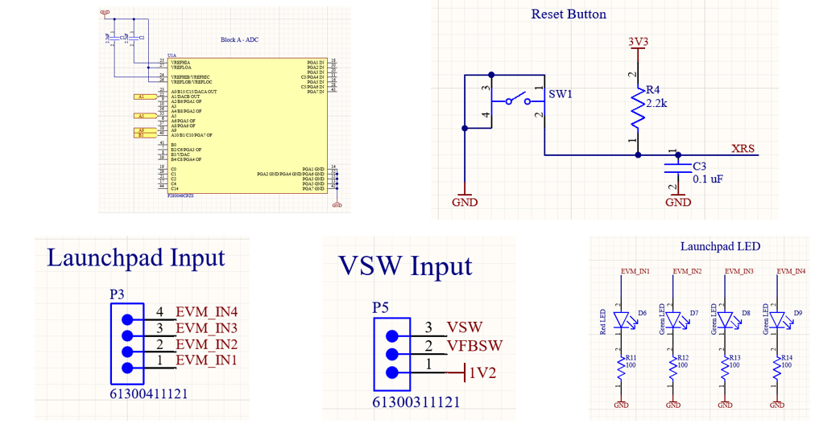

### 3.2.3. C2000 Launchpad Development

To become familiar with programming and developing on the TMS320F280049C MCU, the evaluation board was ordered from Texas Instruments. This evaluation board is developed to allow testing with all features of the MCU. Additionally, TI provides a software development kit (SDK) known as C2000Ware that includes a variety of example codes to begin development on the launchpad.

To program the launchpad, TI’s choice of IDE, Code Composer Studio (CCS) was used. After installation of CCS and C2000Ware, setup of the launchpad was completed by ensuring the correct target device, debug probe, and file configuration was selected.

Using C2000Ware, examples such as “led_ex1_blinky” and “epwm_ex13_up_aq” were used to begin development. LED Blinky allowed control of a GPIO pin to toggle an LED on and off. Additionally, within this source file, additional software was developed to further understand the C2000 MCU. This included a program to spin a MicroServo 9g SG90, a program to spin a step motor 28BYJ-48 with a ULN2003 motor driver, and a program to facilitate communication between an ESP-32 and the C2000 MCU. The ePWM example generated square waveforms for viewing on an oscilloscope. This was successfully outputted for viewing and later on, development of different PWM generation code was written.

The figure below shows the LED Blinky example that was performed on the launchpad. The software writes to GPIO34, sets it high for 1000ms (ON), then sets it low for 1000ms (OFF). The script is in an infinite loop and repeats forever. This example was repeated on the created PCB and demonstrated on demo day.

Figure X: LED Blinky

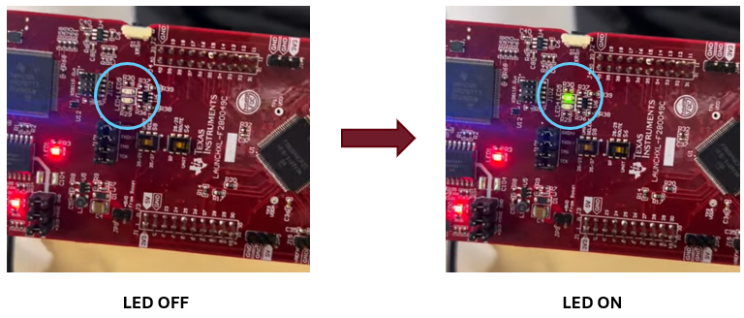

The figure below details another test performed on the launchpad. A MicroServo was used to understand development with GPIO pins. The MicroServo uses 3 pins: GND, 5V, CONTROL. Using GPIO10 as the control, PWM signals were generated ranging 1000μs to 2000μs to rotate the motor from 0° to 180°.

Figure X: MicroServo 9g SG90

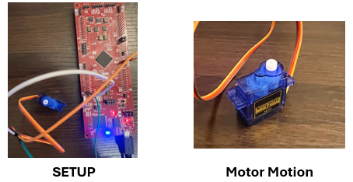

The figure below details a rotating stepper motor example performed on the launchpad. The stepper motor requires four control signals IN1, IN2, IN3, IN4, and 5V. The motor driver supplies IN1, IN2, IN3, IN4, GND, and 5V. The program rotates the stepper motor continuously in one direction through a sequence of GPIO High/Low activations. There are a total of 2038 steps in one full rotation, 90° rotation is shown in the image above. This example was performed on the created PCB and demonstrated on demo day.

Figure X: Stepper Motor w/ ULN2003 Motor Driver

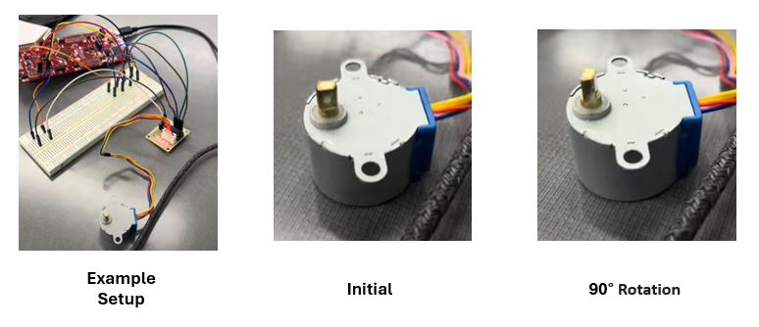

The figure below demonstrates how the launchpad was able to output PWM signals using ePWM1, ePWM2, ePWM3. The oscilloscope is probing GPIO0 which corresponds to ePWM1A. The above image shows the duty cycle changing from 97% to 23%, this is a gradual change in duty cycle to show the difference between the waveforms over time. This was replicated on the PCB and demonstrated on demo day as well.

Figure X: PWM Signal Modulation

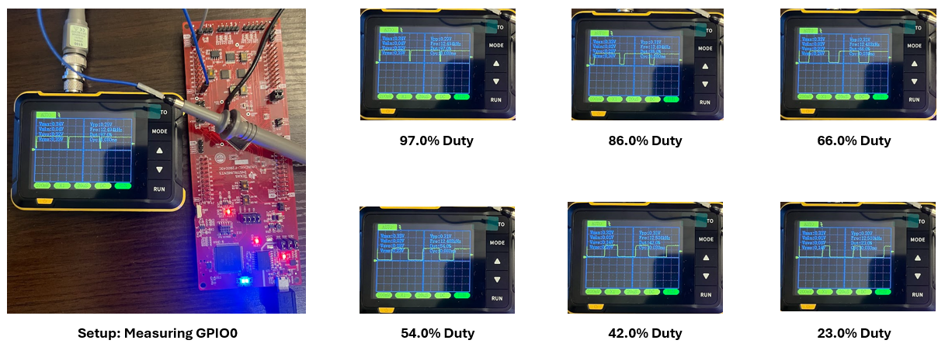

Overall, the launchpad was able to provide a foundation of understanding for developing on a C2000 MCU. All the examples performed on the launchpad were replicated on the PCB board that was developed, with most of them being performed at demo.

### 3.2.4. PCB Testing and Results

The PCB board shown below was created, soldered, and assembled. Throughout the assembly process, the board was debugged to ensure traces were properly routed and correct voltages were delivered. The switch in the top right corner was removed and a trace between GND and SW1 cut as the button was shorting to ground due to an error in schematic. Before this, the device was in a constant state of reset through the XRS pin. Furthermore, the first MCU placed on the PCB had to be removed and replaced as human error led to voltage probing the wrong pin, which destroyed the initial IC.

Figure X: Front & Back of PCB

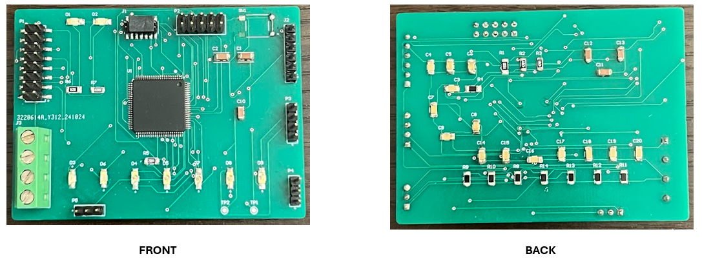

.

#### 3.2.4.1. Power

The PCB requires a 3.3V supply to provide the necessary operating voltage for the MCU. In the lab, this was tested by connecting a 3.3V input to the terminal block on the PCB. To ensure stable operation and no voltage drop off, the power supply was set to 3.3V at 100mA. The amperage was gradually increased on the power supply until no voltage drop off was observed. This ensures integration with the power subsystem, which provides a 3.3V power rail with up to 1A.

Figure X: 3.3V Input to Terminal Block

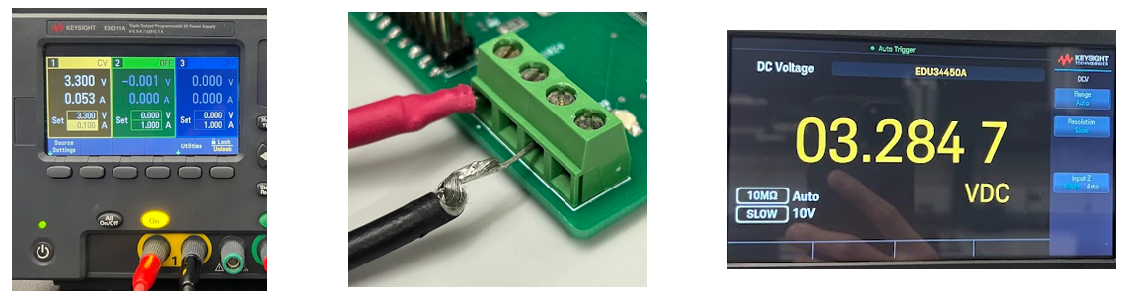

#### 3.2.4.2. Programming

The PCB was able to be programmed through the JTAG protocol. The necessary signals (TDI, TDO, TMS, and TCK) were correctly wired to a header on the PCB that connects to the JTAG header on the launchpad. The launchpad includes a built-in XDS-110 debug probe which is used to interface between the software written on CCS and then build and compile the software onto the target device (TMS320F280049C).

Figure X: Successful JTAG Programming Method

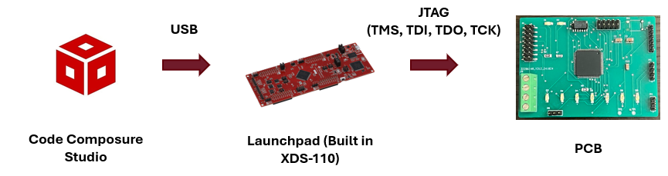

Before the MCU was able to be programmed through the launchpad, there were a series of issues encountered, the following text explains the debugging process to obtain the solution. Originally, the sponsor recommended using an external XDS-110 debug probe. This debug probe would interface between the PC via USB and the PCB via JTAG. This method of programming did not work as the MCU could not detect the probe and a series of errors would occur. This issue was overcome by using the onboard XDS110 that is built into the LAUNCHXL-F280049C (evaluation board). By removing the jumpers off of J101 on the evaluation board, the TDI, TDO, TMS, and TCK signals become available. By connecting the JTAG header from the PCB to the JTAG header on the launchpad, the MCU on the PCB can be programmed through the evaluation board. After doing so, programs are built, compiled, and successfully flashed onto the target MCU.

Figure X: Programming through Launchpad

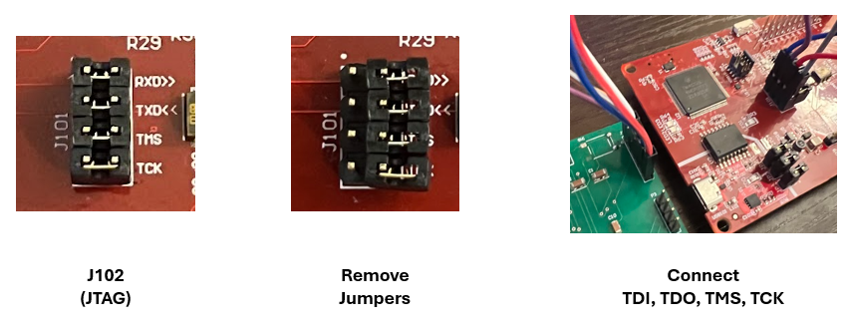

The figure below demonstrates the console output after a program is successfully built, compiled, and flashed onto the MCU.

Figure X: Successful Connection

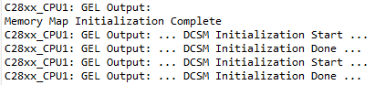

#### 3.2.4.3. PWM Waveform Generation

The PCB was successfully able to generate PWM waveforms that are to be used to drive the high and low gate driver inputs (INH/IN) (INL/EN) on the DRV816x motor driver. The motor driver subsystem will use 3x motor drivers per BLDC motor. Each motor driver will require 2x PWM signals from the MCU. Therefore, per BLDC motor, the MCU subsystem needs to provide 6x PWM signals. The MCU/Processing subsystem can successfully generate the required signals through the use of GPIO0 - GPIO15 with every two GPIOs in this range corresponding to ePWMA and ePWMB for a total of 16x possible PWM signals from one MCU.

The figure below details an oscilloscope screenshot of two PWM waveforms being formed through EPWM7A & EPWM7B at 50kHz. This was generated through the created PCB.

Figure X:PWM Generation EPWM7A & EPWM7B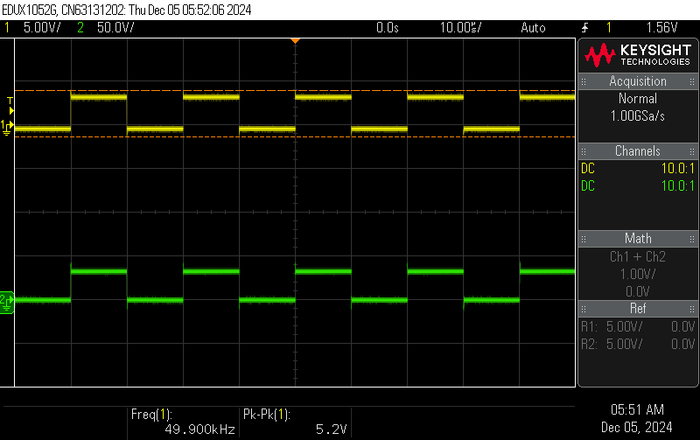

The figure below shows two PWM waveforms being generated from the “epwm_ex13_up_aq” example code. These waveforms are being generated through the created PCB.

Figure X: PWM High/Low Generation

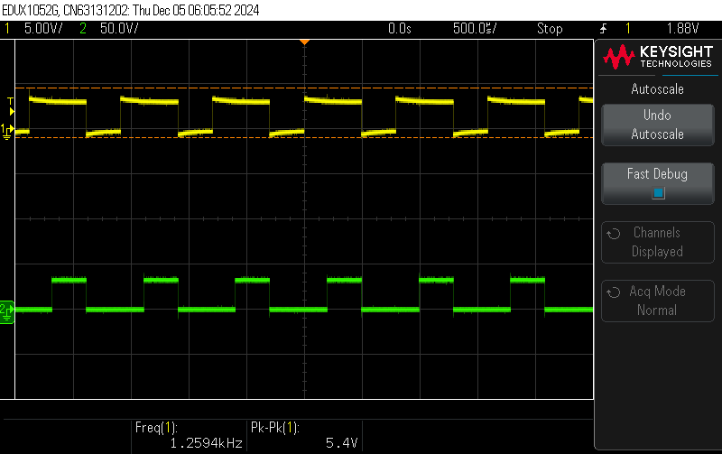

The two previous figures demonstrate that the PCB is capable of generating the required PWM waveforms. The MCU/Processing subsystem will be able to send these PWM signals to the motor driver. The subsystem is ready for integration to the motor driver subsystem. After integration, the exact waveform requirement to rotate a BLDC motor is pending confirmation from the motor driving subsystem and is the next step to spin a motor.

#### 3.2.4.4. Communication with ESP-32

Communication between the ESP-32 and C2000 MCU was successful. The wireless connectivity subsystem will use an ESP-32 to interface with the mobile application. To test connectivity between the ESP-32 and C2000, an ESP-32 was purchased by the MCU/Processing subsystem and development began.

A program was written to toggle GPIO1 to high for 1 second and low for 1 second on the ESP-32. This program ran infinitely to constantly generate a high and low signal. The goal was for the C2000 to recognize this change of input from the ESP-32 and toggle an LED based on if the input is high or low to show that communication between these two devices was successful. To do so, GPIO1 from the ESP32 was connected to GPIO2 on the C2000 MCU. The software developed within CCS used the GPIO_ReadPin function to detect if the input state of GPIO2 was high or low. Based on this, the C2000 would use the GPIO_WritePin function to toggle the GPIOs connected to three LEDs (GPIO4, GPIO5, GPIO6) seen in the figure below.

Figure X: ESP-32/C2000 Setup

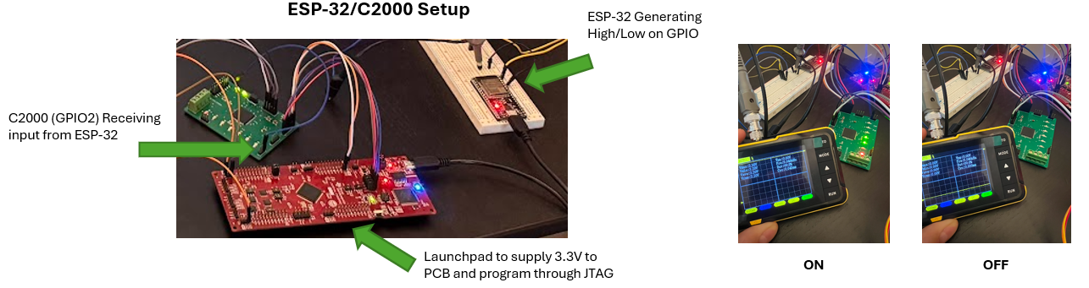

Figure X: ESP-32 to C2000 Communication (LED Toggle)

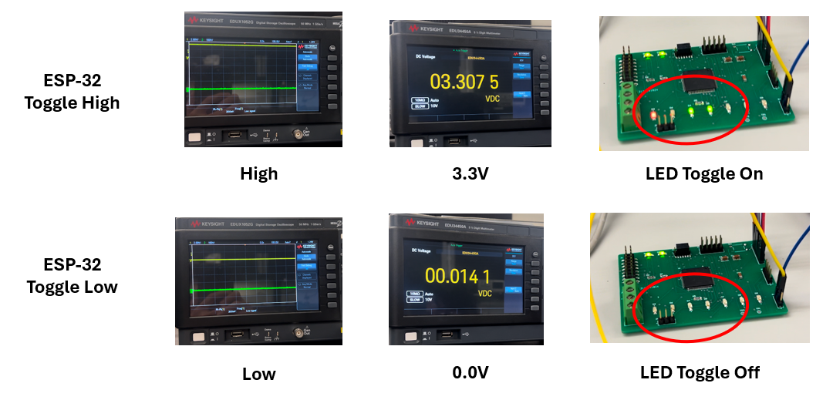

The figure above demonstrates that communication between the ESP-32 and the C2000 was successful by using high/low signal generation on the GPIOs. A similar concept shall be used to integrate with the wireless subsystem next semester. When the user selects movement on the mobile application, (up, down, left, right, open, close) the ESP-32 will toggle a specific pin to high, the C2000 will then detect the input and through a series of if statements, output the desired PWM waveform to send to the motor driver to achieve the desired movement.

### 3.3. Subsystem Validation

The requirements of the MCU/Processing subsystem were validated in accordance with the validation and execution plan. The main objectives of supplying power to board, programming through JTAG, generating PWM waveforms, and receiving signals from the ESP-32 were achieved. Section 3.2.4. “PCB Testing and Results” documents in detail how the deliverables of this subsystem were met and the reported results are shown.

Figure X: Validated Deliverables

| **Deliverable** | **Achieved (Yes/No)** | **How** | **Supporting Figure** |
| --- | --- | --- | --- |
| 3.3V power to PCB | Yes | Terminal block input with 3.3v at 500mA minimum to ensure no voltage drop off. | Figure X |
| JTAG Programming | Yes | JTAG programming through onboard XDS-110 debugger on the launchpad. | Figure X |
| PWM Waveform Generation | Yes | Software written using ePWM modules to generate waveforms on GPIO pins . | Figure X |
| ESP-32/C2000 Communication | Yes | Software written to receive input from ESP-32 through GPIO pins on C2000. Toggle instructions through high/low input. | Figure X |

### 3.4. Subsystem Conclusion

In conclusion, the subsystem performs as expected and will be able to generate and receive the required signals from the different subsystems. The validation and execution plan aided in keeping the MCU/Processing subsystem deliverables on time and aligned with the team members. In the following semester, a new revision of the PCB will be implemented to allow extra freedom and versatility. This will include access to all GPIO pins on the MCU, improved board management, and final revision with team members.

# Power & Battery Management Subsystem

## 4.1. Subsystem Introduction

The power and battery management subsystem is responsible for providing power to the cobot and its associated components. The subsystem uses a PCB to convert the input voltage to five different output voltages, with an additional output voltage that is connected directly to the input. To ensure seamless integration with the other subsystems, this PCB has been designed according to a load list that was developed as a part of planning for this subsystem, which breaks down each component requiring power and records the voltage and current specified by their data sheets. As the cobot is wireless, the input will be a 48V, 20Ah battery, which was selected also based on the load list and for a runtime of 30 minutes. Validation of this subsystem was completed based upon the validation plan to further ensure completeness and success during integration stages.

## 4.2. Subsystem Details

***4.2.1. Planning and Selection***

Initial planning for this subsystem included the development of a load list, which was used to select a battery size and to determine the necessary output voltages, as well as assist the PCB design stage to ensure trace widths would be able to withstand higher current demands of some components. Below is the completed load list.

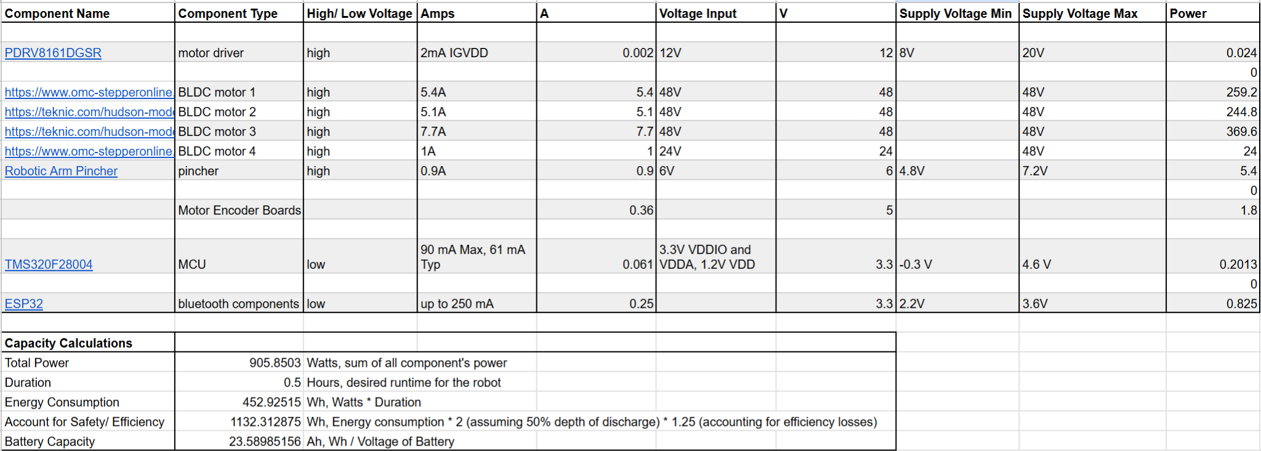

Also included in the load list are calculations for the necessary battery size based on power demands of the system. Assuming a runtime of 30 minutes and a voltage size of 48 volts, a 48 volt 20 amp-hour battery was selected.

Grouping components with the same output voltage together to determine the total current demanded by the voltage rail, TI WeBench was then used to select buck converters that had appropriate voltage output capabilities and current ratings. The intermediate output voltage rails, their current ratings and the selected converters are as followed:

* LM5163DDAR: 3.3V, 0.5V
* LMR36510FADDAR: 5V, 1A
* LM5012DDAR: 6V, 2.5A
* LMR36510FADDAR: 12V, 1A
* LM5164DDAR: 24V, 1A

***4.2.2. Schematic and PCB Design***

### 4.2.2.1. Schematic Design

Using TI WeBench and the load list described above, individual circuits were generated based on input voltage, desired output voltage, and the current rating needed for the circuit. After compiling the five selected circuits, Altium was used to design the individual schematics for each output voltage rail and connect them together through the power and ground nets. During the schematic design stage, terminal blocks were also selected, ensuring each component needing power would have access to a power and ground connection on the PCB.

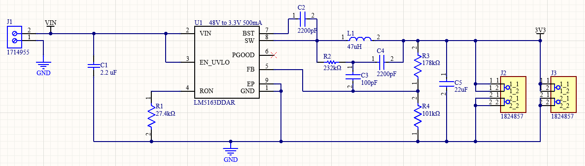.,

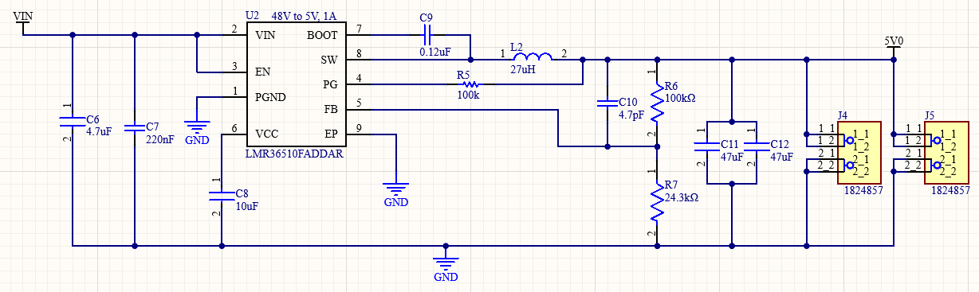

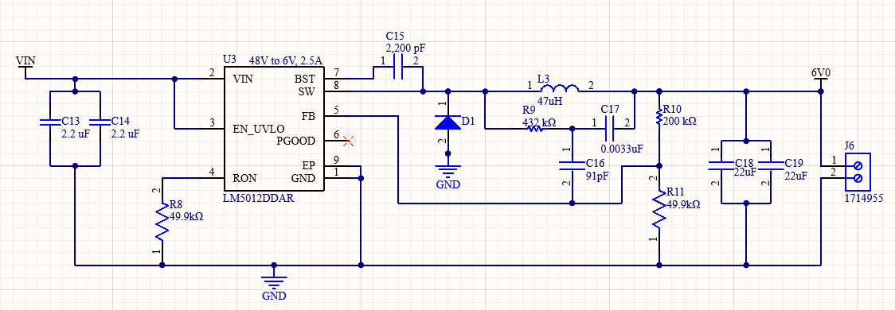

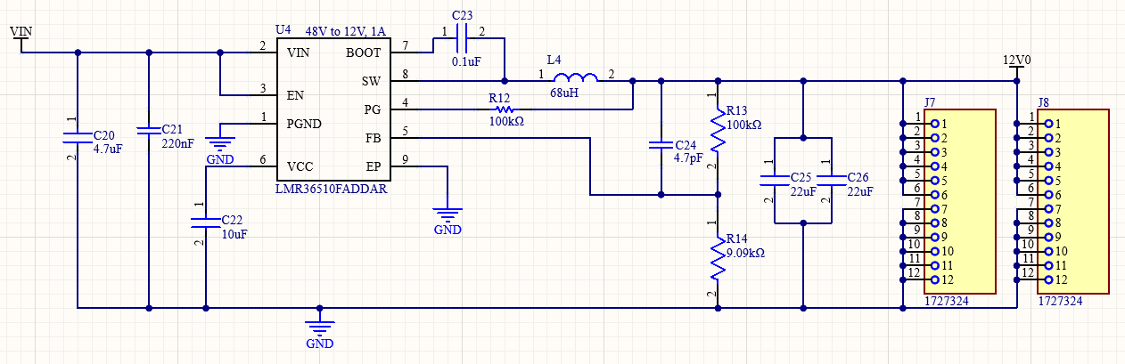

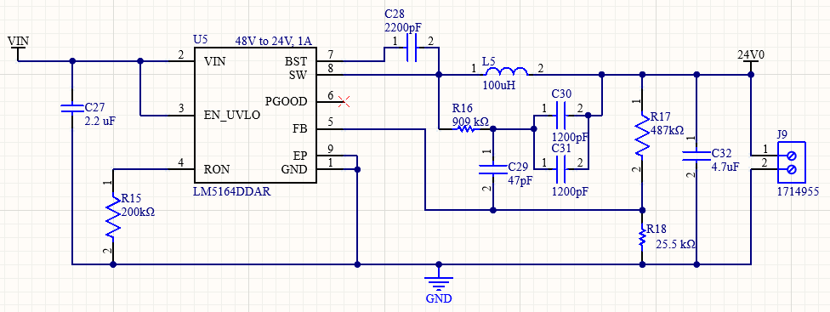

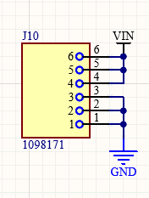

### 4.2.2.2. PCB Design and Fabrication

Layout and routing of the PCB was based on the schematics and the load list. Each step-down circuit was laid out isolated from the others and close to the terminal block providing the output from the converter. Routing and trace widths were determined based on the load list, ensuring that each trace was wide enough to sustain any large amounts of current expected for the load and preparing for integration.

insert board pictures

***4.3. Subsystem Validation***

Validation for this subsystem was done based on the validation plan developed at the beginning of the semester. Within the validation plan there are tests to ensure that the output voltage is reading the correct voltage, and the output voltage is steady and not noisy..

## 4.3.1. Output Voltage Verification

To verify that the output voltage is reading correctly, a digital multimeter was used. The first output voltage to be tested was the 3.3V terminal. When testing this under 25V input and intermediate values leading up to 25V, the output was successful.

*insert picture here*

Testing the 6V, 12V, 24V, and terminal connected directly to the input were also successful when tested with intermediate voltages up to 30V.

*insert pictures*

There were some complications during this testing. When connecting the components to activate the 24V step-down circuit, the converter used in the 3.3V converter circuit shorted between power and ground. Additionally, on the power subsystem PCB, the output of the 5V step-down circuit outputs as much less than one volt. Debugging for both of these issues included testing for continuity throughout the circuit, changing the converters, verifying the designs against TI WeBench, and verifying the components on the board are correct. None of these attempts fixed these issues, and so it is suspected that this is caused by a PCB board layout and routing issue. Further evidence for this is found in the motor and motor driver subsystems’s PCB, as the 3.3V and 5V step down schematics were both used directly as is from the designs developed in this subsystem and are operating as expected, with the only change being the physical layout and routing on the PCB.

While these voltage outputs have not been verified for the full expected input of 48V, once the entirety of the PCB is completed and verified at an intermediate voltage of 30V, there is little concern or doubt that continuing to raise the input voltage to 48V will cause the board to fail a multimeter test.

## 4.3.2. Input and Output Voltage Noise Verification

To ensure that the input and output terminals have limited noise and are truly delivering DC voltage, and oscilloscope was used. When testing the 3.3V and 6V are connected to a 25V input, there is little to no noise in the output or input terminals.

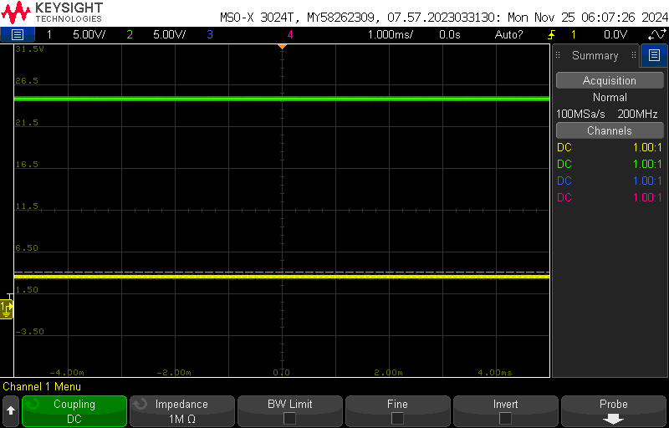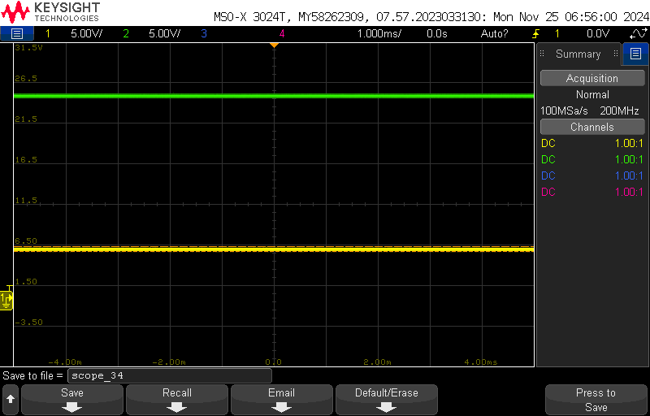

When testing the 24V output with a 30V input, there is also very little noise in the system.

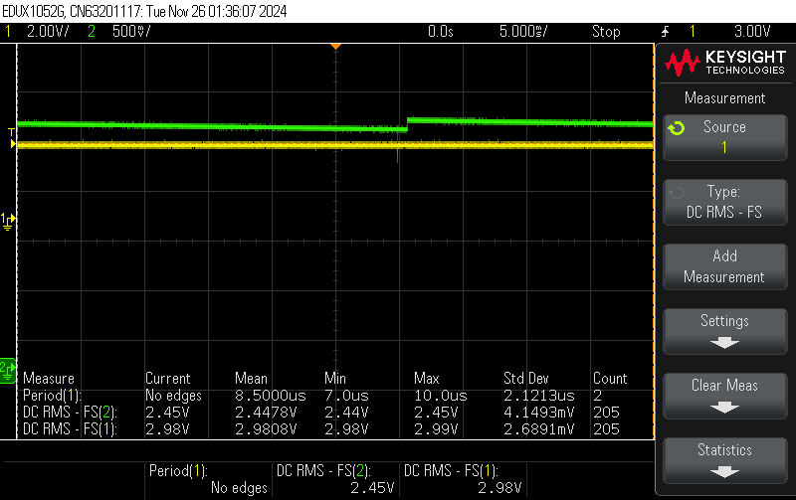

Once adding the 12V output converter

***4.4. Subsystem Conclusion***

Quick introduction paragraph

## 